Database Management System
(DBMS)

LABORATORY WORKBOOK

Name _____________________

Roll No ___________________

Date ______________________

Marks Obtained ____________

Signature___________________

CONTENTS
Lab No | Lab Objective
1 | Introduction to Database
2 | Database Environment
3 | The Relational Data Model
4 | Entity Relationship Model
5 | SQL - Data Definition Language
6 | SQL - Data Manipulation Language
7 | SQL – Data Control Language, Transaction Control Language
8 | Relational Algebra (Structured Query Language)
9 | SQL - Data Manipulation Language Advanced
10 | Structured Query Language

11 | Structured Query Language
12 | Normalization
13 | Normalization with ERD
14 | SQL Stored Procedures
15 | Database Administration

Lab Details

Lab No | Lab Objective | Remarks
1. | Introduction to Database:  Objective: Basic Database concepts, Database applications, Database approach vs. file based system, DBMS, Components and Roles in DBMS Environment, History of DB, Advantages and disadvantages
 | Database Environment:  Objective: Three level architecture, Data independence, Database languages, Data Models, Network and Hierarchical models, Multi user DBMS Architectures, Teleprocessing, File server and Client server architecture, DBMS Functions | Assignment#1
2

3 | The Relational Data Model:  Objective: Relation, attributes, tuples, domains, Relational schema, Relational database, properties of relational data model, keys of relations, integrity constraints | Quiz# 1
4 | Entity Relationship Model:  Objective: Entity and types, Attributes and types, Relationships and types, Keys, attributes on relationships, Entity vs. attributes, Multiplicity, Cardinality, Participation, Entity relationship diagram (ERD)
5 | SQL - Data Definition Language:  Objective: MySQL data types, Create Table, Alter Table, Add and modify Constraints, Create View, View Resolution, View Materialization, updating  Views
6 | SQL - Data Manipulation Language Advanced:  Objective: Joins, Types of Join (Inner, Outer, Left, Right, Natural), computing a join, union, intersect and difference, Insert, bulk insert, update, delete | Assignment #2
7 | SQL – Data Control Language, Transaction Control Language:  Objective: Create User, Grant, Revoke. | Quiz#2
8 | Mid Term Examination
9 | Relational Algebra (Structured Query Language):  Objective: Selection, Projection, Aggregate & grouping operations, relational calculus: History of SQL, SQL Commands, Literals, Data Manipulation Language, MySQL, Select, From, Where, Multiple conditions, IN, Distinct, Between, Like, Null.
10 | SQL - Data Manipulation Language Advanced:  Objective: Joins, Types of Join (Inner, Outer, Left, Right, Natural), computing a join, union, intersect and difference.
Structured Query Language:
Objective: Ordering, aggregate function, group by, having, subquery, BEGIN, END Transaction, Roll back, Commit. ANY & ALL

11 |  | Assignment #3
12 | Normalization: Objective: of normalization, database anomalies, decomposition rules,  Functional dependencies and types, First Normal Form, Second Normal Form, Third Normal Form,  Boyce– Codd Normal Form (BCNF). | Quiz#3
13 | Normalization ERD: Objective: of normalization, database anomalies, decomposition rules, Functional dependencies and types, First Normal Form, Second Normal Form, Third Normal Form,
14 | SQL Stored Procedures: Objective: CRUD, Create, Read, Update and Delete using SQL Stored Procedures with One Parameter & Multiple Parameters. | Assignment#4
15 | Database Administration: Objective: Database Administration that how we Install, Configure, Import & Export Databases | Quiz# 3
16 | Project Submission & Viva

Learning Outcomes:

Sr. No | Course Learning Outcomes
CLO_1 | Analyze the data and data organization needs of organizations
CLO_2 | Apply the Entity-Relationship (E-R) Model for building information systems' data models
CLO_3 | Identify Structure Query Language statements used in creation and manipulation of Database.
CLO_4 | Elaborate on data storage and indexing options, and perform query optimization
CLO_5 | Analyze and design a real database application.use SQL for database creation, manipulation, and control

General Laboratory Procedure
While there is no specific document to be submitted at the beginning of the Lab –unless your instructor advises you otherwise-, you are expected to read the experiment fully before you come to the laboratory? Interestingly, you can even try parts of the experiment at home. Here is a list of programs that will equip you with a virtual lab at your home:
Troubleshooting
Things will not always go as expected; this is the nature of the learning process. While conducting the Experiment think before you do anything. If you do so you will avoid wasting time going down dead-end streets. Be logical and systematic. First, look for obvious errors that are easy to fix. Is your measuring device correctly set and connected? Are you looking at the proper scale? Is the power supply set for the correct voltage? Is the signal generator correctly set and connected? How are the variables in the code set? Is there a syntax error? And so on. Next, check for obvious misconnections or broken connections, at least in simple circuits.
As you work through your circuit, use your Lab Manual record tests and changes that you make as you go along; don't rely on your memory for what you have tried. Identify some test points in the system at which you know what the signal should be and work your way backwards from the output through the test points until you find a good signal. Neatness
When you have finished for the day, return all modules to their proper storage bins, return all test leads and probes to their storage racks, return all equipment to its correct location, and clean up the lab station. If appropriate switch off the unneeded equipment. Save your files in the Computer and on any USB device for your records because you might not get the same PC System again for the next experiment. Also email your file contents to your email address as a backup.

Laboratory Safety

Always pay attention to what you are doing and you’re surrounding during the experiments, notify the Instructor for any unlikely event or mishap, and leave the Laboratory with the permission of Instructor immediately.
All students must read and understand the information in this document with regard to laboratory safety and emergency procedures prior to the first laboratory session.
Your personal laboratory safety depends mostly on YOU. Efforts have been made to address situations that may pose a hazard in the lab but the information and instructions provided cannot be considered allinclusive.
Students must adhere to written and verbal safety instructions throughout the academic term. Since additional instructions may be given at the beginning of laboratory sessions, it is important that all students arrive at each session on time. With good judgment, the chance of an accident in this course is very small. Nevertheless, research and teaching workplaces (labs, shops, etc.) are full of potential hazards that can cause serious injury and or damage to the equipment. Working alone and unsupervised in laboratories is forbidden if you are working with hazardous substances or equipment. With prior approval, at least two people should be present so that one can shut down equipment and call for help in the event of an emergency. Safety training and/or information should be provided by a faculty member, teaching assistant, lab safety contact, or staff member at the beginning of a new assignment or when a new hazard is introduced into the workplace.
Emergency Response
- It is your responsibility to read safety and fire alarm posters and follow the instructions during an emergency
- Know the location of the fire extinguisher, eye wash, and safety shower in your lab and know how to use them.
- Notify your instructor immediately after any injury, fire or explosion, or spill.
- Know the building evacuation procedures.
Common Sense
Good common sense is needed for safety in a laboratory. It is expected that each student will work in a responsible manner and exercise good judgment and common sense. If at any time you are not sure how to handle a particular situation, ask your Teaching Assistant or Instructor for advice DO NOT TOUCH ANYTHING WITH WHICH YOU ARE NOT COMPLETELY FAMILIAR!!! It is always better to ask questions than to risk harm to yourself or damage to the equipment.
Personal and General laboratory safety
- Never eat, drink, or smoke while working in the laboratory.
- Read labels carefully.

- Do not use any equipment unless you are trained and approved as a user by your supervisor.
- Wear safety glasses or face shields when working with hazardous materials and/or equipment.
- Wear gloves when using any hazardous or toxic agent.
- Clothing: When handling dangerous substances, wear gloves, laboratory coats, and safety shield or glasses. Shorts and sandals should not be worn in the lab at any time. Shoes are required when working in the machine shops.
- If you have long hair or loose clothes, make sure it is tied back or confined.
- Keep the work area clear of all materials except those needed for your work. Coats should be hung in the hall or placed in a locker. Extra books, purses, etc. should be kept away from equipment that requires air flow or ventilation to prevent overheating.
- Disposal - Students are responsible for the proper disposal of used material if any in appropriate containers.
- Equipment Failure - If a piece of equipment fails while being used, report it immediately to your lab assistant or tutor. Never try to fix the problem yourself because you could harm yourself and others.
- If leaving a lab unattended, turn off all ignition sources and lock the doors.
- Never pipette anything by mouth.
- Clean up your work area before leaving.
- Wash hands before leaving the lab and before eating.
- Unauthorized person(s) shall not be allowed in a laboratory for any reason Electrical safety
- Obtain permission before operating any high voltage equipment.
- Maintain an unobstructed access to all electrical panels.
- Wiring or other electrical modifications must be referred to the Electronics Shop or the Building Coordinator.
- Avoid using extension cords whenever possible. If you must use one, obtain a heavy- duty one that is electrically grounded, with its own fuse, and install it safely. Extension cords should not go under doors, across aisles, be hung from the ceiling, or plugged into other extension cords.
- Never, ever modify, attach or otherwise change any high voltage equipment.
- Always make sure all capacitors are discharged (using a grounded cable with an insulating handle) before touching high voltage leads or the "inside" of any equipment even after it has been turned off. Capacitors can hold charge for many hours after the equipment has been turned off.
- When you are adjusting any high voltage equipment or a laser which is powered with a high voltage supply, USE ONLY ONE HAND. Your other hand is best placed in a pocket or behind your back. This procedure eliminates the possibility of an accident where high voltage current flows up one arm, through your chest, and down the other arm.
- Discard damaged cords, cords that become hot, or cords with exposed wiring.
- Before equipment is energized ensure, (1) circuit connections and layout have been checked by a Teaching Assistant (TA) and (2) all colleagues in your group give their assent.
- Know the correct handling, storage and disposal procedures for batteries, cells, capacitors, inductors and other high energy-storage devices.
- Experiments left unattended should be isolated from the power supplies. If for a special reason, it must be left on, a barrier and a warning notice are required.
- Equipment found to be faulty in any way should be reported to the Lab Engineer immediately and taken out of service until inspected and declared safe.
- Voltages above 50 V rms AC and 120 V DC are always dangerous. Extra precautions should be considered as voltage levels are increased.
- Never make any changes to circuits or mechanical layout without first isolating the circuit by switching off and removing connections to power supplies.
- Know what you must do in an emergency.
- Emergency Power Off: Every lab is equipped with and Emergency Power Off System.
- Only authorized personnel are permitted to reset power once the Emergency Power Off system has been engaged.
Electrical Emergency Response
The following instructions provide guidelines for handling two types of electrical emergencies:
- When someone suffers serious electrical shock, he or she may be knocked unconscious. If the victim is still in contact with the electrical current, immediately turn off the electrical power source. If you cannot disconnect the power source, depress the Emergency Power Off switch.
- Do not touch a victim that is still in contact with a live power source; you could be electrocuted.
- Have someone call for emergency medical assistance immediately. Administer first-aid, as appropriate.
- If an electrical fire occurs, try to disconnect the electrical power source, if possible. If the fire is small and you are not in immediate danger; and you have been properly trained in fighting fires, use the correct type of fire extinguisher to extinguish the fire. When in doubt, push in the Emergency Power Off button.
- NEVER use water to extinguish an electrical fire. Mechanical safety
- When using compressed air, use only approved nozzles and never direct the air towards any person.
- Guards on machinery must be in place during operation.

- Exercise care when working with or near hydraulically- or pneumatically-driven equipment. Sudden or unexpected motion can inflict serious injury. Additional Safety Guidelines 1. Never do unauthorized experiments.
- Never work alone in laboratory.
- Keep your lab space clean and organized.
- Do not leave an on-going experiment unattended.
- Always inform your instructor if you break a thermometer. Do not clean mercury yourself!!
- Never taste anything. Never pipette by mouth; use a bulb.
- Never use open flames in laboratory unless instructed by TA.
- Check your glassware for cracks and chips each time you use it. Cracks could cause the glassware to fail during use and cause serious injury to you or lab mates.
- Maintain unobstructed access to all exits, fire extinguishers, electrical panels, emergency showers, and eye washes.
- Do not use corridors for storage or work areas.
- Do not store heavy items above table height. Any overhead storage of supplies on top of cabinets should be limited to lightweight items only. Also, remember that a 36" diameter area around all fire sprinkler heads must be kept clear at all times.
- Areas containing lasers, biohazards, radioisotopes, and carcinogens should be posted accordingly. However, do not post areas unnecessarily and be sure that the labels are removed when the hazards are no longer present.
- Be careful when lifting heavy objects. Only shop staff may operate forklifts or cranes.
- Clean your lab bench and equipment, and lock the door before you leave the laboratory. Clothing
- Dress properly during a laboratory activity.
- Long hair, dangling jewelry, and loose or baggy clothing are a hazard in the laboratory.
- Long hair must be tied back, and dangling jewelry and baggy clothing must be secured.
- Shoes must completely cover the foot.
- No sandals allowed on lab days.
- A lab coat or smock should be worn during laboratory experiments. Accidents and Injuries 1. Do not panic.

- Report any accident (spill, breakage, etc.) or injury (cut, burn, etc.) to the teacher immediately, no matter how trivial it seems.
- If you or your lab partner is hurt, immediately (and loudly) yell out the teacher's name to get the teacher's attention.

General Warning Signs

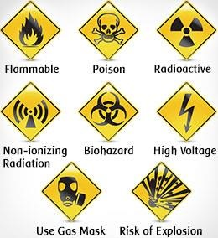

LAB # 01

The Purpose of this Lab is to get familiar with the File System & File Handling

Name
Date
Registration No
Department
Quiz
Assignment

___________________
Lab Instructor Signature

File System & File Handling Experiment
01
Objective

The Purpose of this Lab is to get familiar with the File System & File Handling
Theory

File System
A file system is the methods and data structures that an operating system uses to keep track of files on a disk or partition; that is, the way the files are organized on the disk. The word is also used to refer to a partition or disk that is used to store the files or the type of the file system. Thus, one might say ``I have two file systems'' meaning one has two partitions on which one stores files, or that one is using the ``extended file system'', meaning the type of the file system.
The difference between a disk or partition and the file system it contains is important. A few programs (including, reasonably enough, programs that create file systems) operate directly on the raw sectors of a disk or partition; if there is an existing file system there it will be destroyed or seriously corrupted. Most programs operate on a file system, and therefore won't work on a partition that doesn't contain one (or that contains one of the wrong type).
Before a partition or disk can be used as a file system, it needs to be initialized, and the bookkeeping data structures need to be written to the disk. This process is called making a file system.

Block Size
The block size specifies size that the file system will use to read and write data. Larger block sizes will help improve disk I/O performance when using large files, such as databases. This happens because the disk can read or write data for a longer period of time before having to search for the next block.
On the downside, if you are going to have a lot of smaller files on that file system, like the /etc, there the potential for a lot of wasted disk space.
For example, if you set your block size to 4096, or 4K, and you create a file that is 256 bytes in size, it will still consume 4K of space on your hard drive. For one file that may seem trivial, but when your file system contains hundreds or thousands of files, this can add up.
Block size can also effect the maximum supported file size on some file systems. This is because many modern file system are limited not by block size or file size, but by the number of blocks. Therefore you would be using a "block size * max # of blocks = max block size" formula.

File System comparison

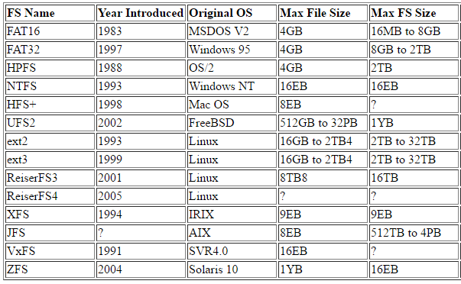

How we can check which the file system in MS Windows?

Go to > Computer, right-click on the drive you wish to examine, and select > Properties from the menu. The > General tab shows the > File system.

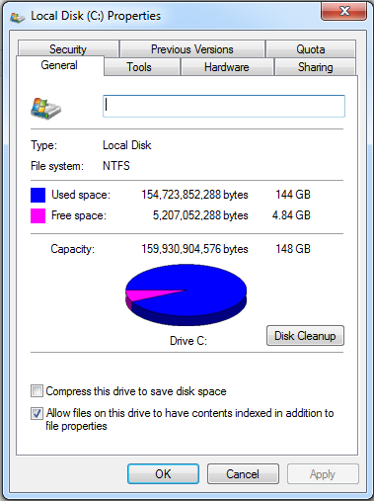

Exercise

Question 1:

What are the disadvantages of file processing system?
Feedback

Before databases were introduced data was always stored in hierarchical order called file systems
But with the advancement of internet multiple new technologies were introduced which needed all sorts of data for this client server needs database was introduced.
File server has following disadvantages:
1)inaccessibility: file server cannot fetch the specific data but only the whole file, which means wastage of storage and data.

2)complex: In file server if you need a data you will have to recall the file name, file location and even after that multiple permissions are required.

3)Concurrency: the biggest disadvantage of file server is that it can not provide concurrency to its users meaning multiple users can not access the same data at the same time.

LAB # 02

The Purpose of this Lab is to get familiar with the Relational DBMS Architecture & its Concepts

Name
Date
Registration No
Department
Quiz
Assignment

___________________
Lab Instructor Signature

Relational DBMS Architecture Experiment
02
Objective

The Purpose of this Lab is to get familiar with the Relational DBMS Architecture & its Concepts
Theory

RDBMS: Overview
- A relational database management system (RDBMS):
  - Manages data according to the relational model
  - Organizes and stores data in the form of tables
  - Example: A bank database has tables for currency data, customer information, account information, and so on.
- A database is a collection of data placed in tables.
  - Synonymous with “schema”
- The relational model
  - Data logically organized as tables and relations
  - An improvement over the hierarchical database model, which has the following problems:
    - Requires additional steps to coordinate the data and programs
    - Difficult to develop applications and perform required operations
- In the relational model, the fundamental structure to organize data is the “relation,” which is where it gets its name. For most purposes, the term “table” is interchangeable with the more abstract term “relation.” The term “table” is used in the remainder of this course.
- “Database” is MySQL terminology. Other RDBMSs use the term “schema.”
- For example, a database for a bank might contain a table to store currency data, a table to store customer data, and a table for its accounts. These tables are obviously related: a customer can have one or more accounts, and an account can express its balance in a particular currency. However, the existence of these relationships is not a defining characteristic of a relational database. The only reason for a DBMS to be called relational is that it stores its data in tables, regardless of whether or not these tables are related to one another.
- Continuing with the bank example, a hierarchical representation would require a list of customers and, within each customer entry, a list of bank accounts, which contain a currency. To list all used currencies, you must first examine all the customers and then, for each customer, you must look at all accounts. This shows a case for using the relational model over the hierarchical model, which requires many additional steps to coordinate the data and programs that work with a database. The hierarchical model makes it incredibly time consuming to develop applications and to perform many required operations.
Spreadsheet versus Database
  - Spreadsheets are flexible and provide more user interface features:
    - Allow any data to be entered into a cell
    - Convert data into graphs
    - Format directly into printable reports with header and footer
  - Databases are much more powerful than spreadsheets due to data query and manipulation capabilities:
    - Retrieve all records that match certain criteria
    - Cross-reference records between tables
    - Update records in bulk
    - Perform complex aggregate calculations
Entities and Relationships
- Entities: Things in the real world that you store information about in a database.
  - Tables typically store data representing one type of entity.
  - Example:
    - A bank database has a customer table specifically for customer information.
    - The customer table can contain entities/columns such as the customer name, account number, and contact information.
- Relationships: Links between entities that have something to do with each other.
  - Example:
    - The bank customer name has a relationship to the customer account number and contact information.
There can also be relationships between separate tables (for example, customer to accounts).
You cannot literally store things in a database, nor any relationships they might have. What you can store in a database is data. Storing information about things such as customers, bank accounts and currencies in our database, means that you store data in your database that represents these real-world things.
In relational databases, one table is typically used to store data that represents entities of one particular kind. As in the bank example, the customers table is used to store items of data, each of which represents exactly one entity of the "customer" kind.
Relationship Categories
Relationship categories and examples:
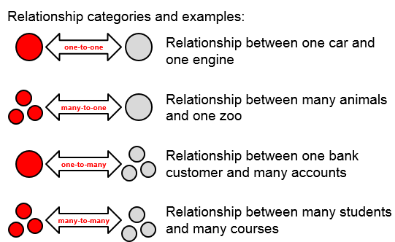
Relationships can be categorized according to how many entities can possibly be involved at either end of the relationship.
In the slide example of a one-to-one relationship, a car has one engine, and the engine can belong to only one car. There is a one-to-one relationship between the car and the engine. Often these types of relationships are put in the same table, but not always.
In the slide example of a one-to-many relationship, an individual customer of a bank can have more than one account. Note that this allows for customers to have zero, one, or more bank accounts. The word many refer to the maximum number of possible bank accounts for each customer. Alternatively, a bank account is tied to a single customer only. That is why this is a one-to-many relationship.
There is a many-to-many relationship between students and courses. A student can attend more than one course and a course can be attended by many students.

RDBMS Database Structure
- Two-dimensional tables, columns, and rows:
  - An ordered set of columns (1 or more)
  - An unordered set of rows (0 or more)
- Each table row has exactly one value for each column.
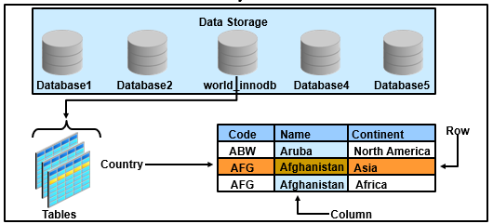
Row-Column Relationship
- Rows are a collection of values that describe an entity (such as a bank account).
- Columns are a collection of similar data among rows (such as customer surnames). Each column has a name and a data type.
- The intersection of row and column contains individual data items called values. Values are always atomic, that is, each position in a table may contain only one datum (piece of data). If you have ever used a spreadsheet, you have used a table of data.
It is common to present data in a simple two-dimensional table form. The relational model stipulates that a relation must have unique tuples—no two entities can be identical or you would not be able to distinguish one from the other. There must be some combination of columns (possibly, all columns) called a key, whose values uniquely identify each tuple. Most RDBMSs are less strict. Virtually all of them allow a table to contain duplicate rows, and allow a table to exist without a key.
Note: In SQL, tables are not required to have primary keys. In other words, the requirement of the relational model is not enforced in SQL. However, it is enforced as soon as a primary key is added to the table. A detailed discussion of primary keys, and how to create them, is provided later in the course.

Exercise

Question 1
Modern School of higher education has around 2000 students and three departments. The students belong to various departments in the school. Every department has a Head of Department along with teachers. The head of department manages his departmental teachers and the students belonging to his department. The head of department also teaches the students. All the head of departments report to the Principal of the school. The Principal manages the departments and also teaches the students. Handling the administrative staff of the school is also the responsibility of the Principal. Every individual, except the students, are the employees of the school
Problem
- Identify the entity
- Identify the entity’s attribute
- Identify the primary and foreign Keys
- Identify relationship between Entities
- Identify the Cardinality constraints

Answer:

Entities and attributes:

1)School
2)Students=name, ID ,
3)departments=faculty name, courses
Question 2
- a professor teaches zero, one or many classes and a class is taught by one professor
- a course may generate zero, one or many classes and a class comes from one course
- a class is held in one room but a room has many classes

Feedback

LAB # 03

The Purpose of this Lab is to introduce Entity Relationship Diagram & its Notations

Name
Date
Registration No
Department
Quiz
Assignment

___________________
Lab Instructor Signature

Entity Relationship Diagram – Introduction Experiment
03
Objective

The Purpose of this Lab is to introduce Entity Relationship Diagram & its Notations
Theory

Notations
Entities Notation
Symbol | Shape Name | Description
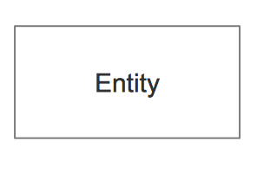 | Entity | An entity is represented by a rectangle which contains the entity’s name.
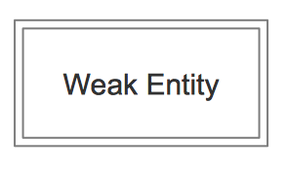 | Weak Entity | An entity that cannot be uniquely identified by its attributes alone. The existence of a weak entity is dependent upon another entity called the owner entity. The weak entity’s identifier is a combination of the identifier of the owner entity and the partial key of the weak entity.
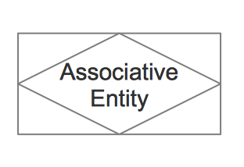 | Associative Entity | An entity used in a many-to-many relationship (represents an extra table). All relationships for the associative entity should be many

Attributes Notation
Symbol | Shape Name | Description
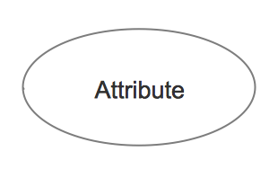 | Attribute | Each attribute is represented by an oval containing attribute’s name
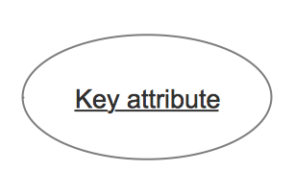 | Key attribute | An attribute that uniquely identifies a particular entity. The name of a key attribute is underscored.
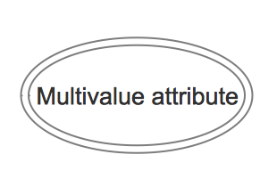 | Multivalued attribute | An attribute that can have many values (there are many distinct values entered for it in the same column of the table). Multivalued attribute is depicted by a dual oval.
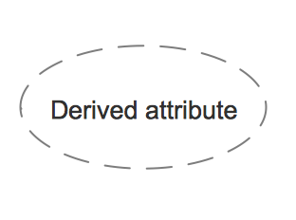 | Derived attribute | An attribute whose value is calculated (derived) from other attributes. The derived attribute may or may not be physically stored in the database. In the Chen notation, this attribute is represented by dashed oval.

Relationship Notation
Symbol | Shape Name | Description
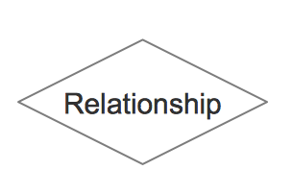 | Strong relationship | A relationship where entity is existence-independent of other entities, and PK of Child doesn’t contain PK component of Parent Entity. A strong relationship is represented by a single rhombus
 | Weak (identifying) relationship | A relationship where Child entity is existence-dependent on parent, and PK of Child Entity contains PK component of Parent Entity. This relationship is represented by a double rhombus.

ER Model is represented by means of an ER diagram. Any object, for example, entities, attributes of an entity, relationship sets, and attributes of relationship sets, can be represented with the help of an ER diagram.

Entity
Entities are represented by means of rectangles. Rectangles are named with the entity set they represent.

Attributes
Attributes are the properties of entities. Attributes are represented by means of ellipses. Every ellipse represents one attribute and is directly connected to its entity (rectangle).
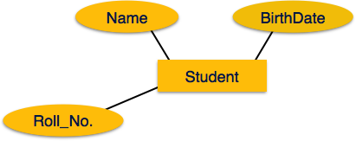
If the attributes are composite, they are further divided in a tree like structure. Every node is then connected to its attribute. That is, composite attributes are represented by ellipses that are connected with an ellipse.
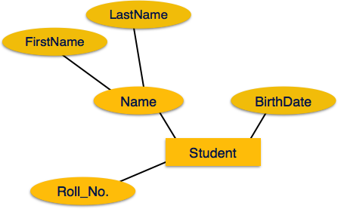

Multivalued attributes are depicted by double ellipse.
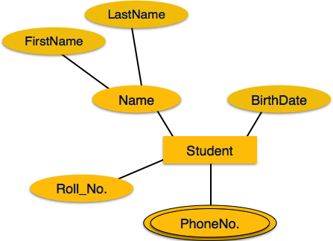

Derived attributes are depicted by dashed ellipse.
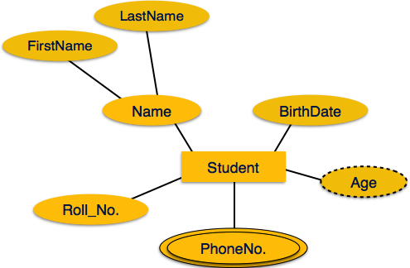

Relationship
Relationships are represented by diamond-shaped box. Name of the relationship is written inside the diamond-box. All the entities (rectangles) participating in a relationship, are connected to it by a line.

Binary Relationship and Cardinality
A relationship where two entities are participating is called a binary relationship. Cardinality is the number of instance of an entity from a relation that can be associated with the relation.
- One-to-one − when only one instance of an entity is associated with the relationship, it is marked as '1:1'. The following image reflects that only one instance of each entity should be associated with the relationship. It depicts one-to-one relationship.
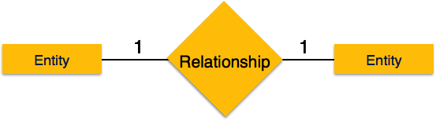
- One-to-many − When more than one instance of an entity is associated with a relationship, it is marked as '1:N'. The following image reflects that only one instance of entity on the left and more than one instance of an entity on the right can be associated with the relationship. It depicts one-to-many relationship.
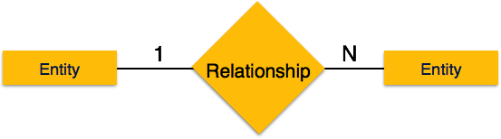
- Many-to-one − when more than one instance of entity is associated with the relationship, it is marked as 'N:1'. The following image reflects that more than one instance of an entity on the left and only one instance of an entity on the right can be associated with the relationship. It depicts many-to-one relationship.
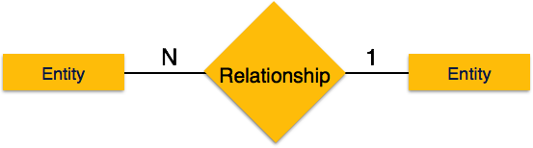
- Many-to-many − The following image reflects that more than one instance of an entity on the left and more than one instance of an entity on the right can be associated with the relationship. It depicts many-to-many relationship.
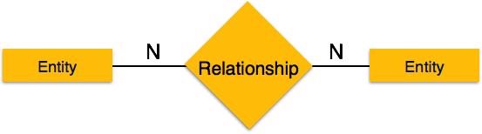

Participation Constraints
- Total Participation – Each entity is involved in the relationship. Total participation is represented by double lines.
- Partial participation − Not all entities are involved in the relationship. Partial participation is represented by single lines.
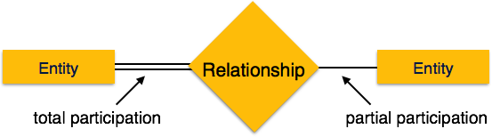
Exercise

Question 1
Modern School of higher education has around 2000 students and three departments. The students belong to various departments in the school. Every department has a Head of Department along with teachers. The head of department manages his departmental teachers and the students belonging to his department. The head of department also teaches the students. All the head of departments report to the Principal of the school. The Principal manages the departments and also teaches the students. Handling the administrative staff of the school is also the responsibility of the Principal. Every individual, except the students, are the employees of the school
- Identify the entity
- Identify the entity’s attribute
- Identify the primary and foreign Keys
- Identify relationship between Entities
- Identify the Cardinality constraints
- Draw ERD

Question 2
- an invoice is written by one sales rep but a sales rep writes many invoices
- a vendor sells many products but a product is bought from one vendor
- an invoice has one or many products and a product is found on zero, one or many invoices
- Identify the entity
- Identify the entity’s attribute
- Identify the primary and foreign Keys
- Identify relationship between Entities
- Identify the Cardinality constraints
- Draw ERD

Feedback

LAB # 04

The Purpose of this Lab is to make Entity Relationship Diagram by using Case Studies

Name
Date
Registration No
Department
Quiz
Assignment

___________________
Lab Instructor Signature

Entity Relationship Diagram – Case Study Experiment
04
Objective

The Purpose of this Lab is to make Entity Relationship Diagram by using Case Studies
Theory

CASE - STUDY
Consider the following information about a university database:
- Professors have an SSN, a name, an age, a rank, and a research specialty.
- Projects have a project number, a sponsor name (e.g., NSF), a starting date, an ending date, and a budget.
- Graduate students have an SSN, a name, an age, and a degree program (e.g., M.S. or Ph.D.).
- Each project is managed by one professor (known as the project’s principal investigator).
- Each project is worked on by one or more professors (known as the project’s co-investigators).
- Professors can manage and/or work on multiple projects.
- Each project is worked on by one or more graduate students (known as the project’s research assistants).
- When graduate students work on a project, a professor must supervise their work on the project. Graduate students can work on multiple projects, in which case they will have a (potentially different) supervisor for each one.
- Departments have a department number, a department name, and a main office.
- Departments have a professor (known as the chairman) who runs the department.
- Professor’s work in one or more departments and for each department that they work in, a time percentage is associated with their job.
- Graduate students have one major department in which they are working on their degree.
- Each graduate student has another, more senior graduate student (known as a student advisor) who advises him or her on what courses to take.

Design and draw an ER diagram that captures the information about the university.
Use only the basic ER model here; that is, entities, relationships, and attributes. Be
Sure to indicate any key and participation constraints.

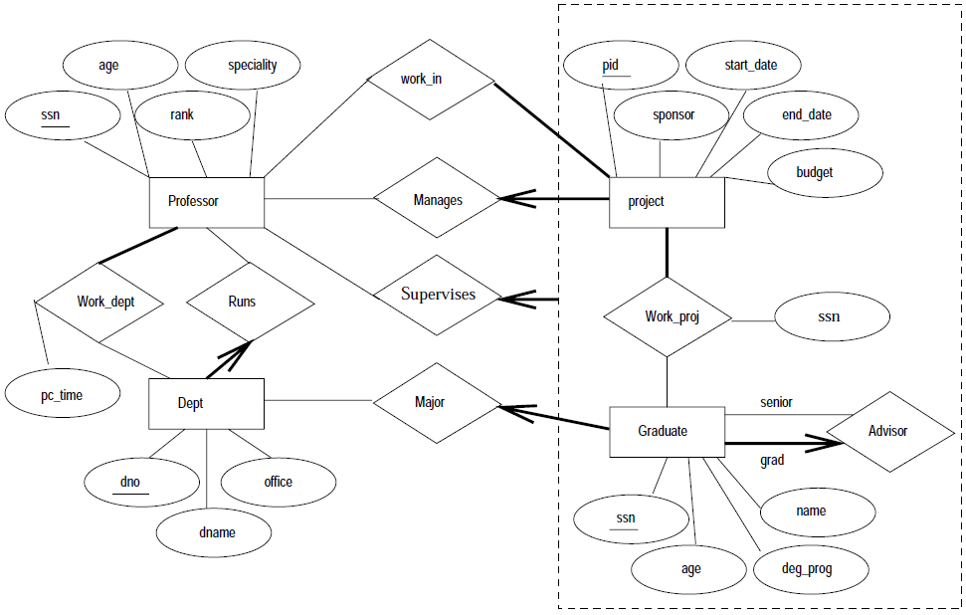

Exercise

CASE - STUDY -II
The Prescriptions-R-X chain of pharmacies has offered to give you a free lifetime supply of medicine if you design its database. Given the rising cost of health care, you agree. Here’s the information that you gather:
- Patients are identified by an SSN, and their names, addresses, and ages must be recorded.
- Doctors are identified by an SSN. For each doctor, the name, specialty, and years of experience must be recorded.
- Each pharmaceutical company is identified by name and has a phone number.
- For each drug, the trade name and formula must be recorded. Each drug is sold by a given pharmaceutical company, and the trade name identifies a drug uniquely from among the products of that company. If a pharmaceutical company is deleted, you need not keep track of its products any longer.
- Each pharmacy has a name, address, and phone number.
- Every patient has a primary physician. Every doctor has at least one patient.
- Each pharmacy sells several drugs and has a price for each. A drug could be sold at several pharmacies, and the price could vary from one pharmacy to another.
- Doctors prescribe drugs for patients. A doctor could prescribe one or more drugs for several patients, and a patient could obtain prescriptions from several doctors.
- Each prescription has a date and a quantity associated with it. You can assume that, if a doctor prescribes the same drug for the same patient more than once, only the last such prescription needs to be stored.
- Pharmaceutical companies have long-term contracts with pharmacies. A pharmaceutical company can contract with several pharmacies, and a pharmacy can contract with several pharmaceutical companies. For each contract, you have to store a start date, an end date, and the text of the contract.
- Pharmacies appoint a supervisor for each contract. There must always be a supervisor for each contract, but the contract supervisor can change over the lifetime of the contract.
Draw an ER diagram that captures the preceding information. Identify any constraints not captured by the ER diagram.
How would your design change if each drug must be sold at a fixed price by all pharmacies?
How would your design change if the design requirements change as follows: If a doctor prescribes the same drug for the same patient more than once, several such prescriptions may have to be stored?

Feedback

LAB # 05

The Purpose of this Lab is to introduce the DDL (Data Definition Language) which includes Create, Drop, and Alter & Truncate Statements

Name
Date
Registration No
Department
Quiz
Assignment

___________________
Lab Instructor Signature

Introduction to DDL Experiment
05
Objective

The Purpose of this Lab is to introduce the DDL (Data Definition Language) which includes Create, Drop, and Alter & Truncate Statements
Theory

Data Definition Language: SQL Statements
The DDL SQL statements are used to define database and table data. The statements shown in the slide are followed by options to specify data operations.
Creating a Database
- General syntax for creating a database:
- CREATE SCHEMA is a synonym for CREATE DATABASE.
- Example:
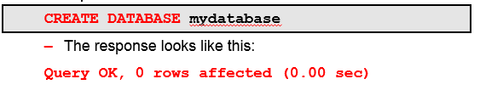
When your database design is complete, create the actual database by using the MySQL statement CREATE DATABASE. It is important for you to name the database according to its purpose. After the database is created, you can add the tables.
You can add the IF NOT EXISTS option statement. An error occurs if the database exists and you did not specify IF NOT EXISTS.
For more information about creating a database, see the MySQL Reference Manual at http://dev.mysql.com/doc/refman/5.5/en/create-database.html.
MySQL Naming Conventions
- Database and table names are generally not
case-sensitive, but this depends on the file system.
- You cannot use certain characters, including ASCII (0), ASCII (255), /, \, and .
- Names cannot have more than 64 characters.
- You can use reserved words and special characters in quotation marks.
MySQL in general does not consider names (databases and tables) to be case-sensitive. However, it does treat them as case-sensitive if the file system on which the database resides is itself case-sensitive.
Table names can be (or contain) reserved words as long as the name is quoted (such as a table named 'my_ table' or '$'), but this practice is discouraged.
Creating a Table
- General syntax for creating a table:
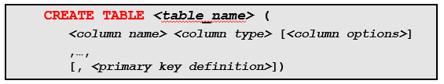
- Example:
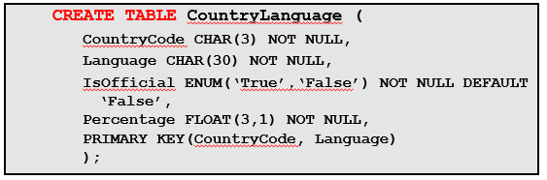
After the database structure is designed and the database has been created, you can add the individual tables. You must use accurate assignment of data types and options, then you can add the tables from the design plan to the database. Table and column options are covered later in this lesson.
Creating tables is a complex topic due to the process of choosing how to create the table and the syntax, which consists of many elements. The statement syntax shown in the slide includes the column and table options.
A line-by-line description of the CREATE TABLE example:
- Creates a table called CountryLanguage"(" is the beginning of the table structure definition that ends with ")".
- The column named CountryCode is assigned the data type of CHAR and maximum length of 3 characters that cannot accept NULL. The comma at the end of the line indicates that you are continuing to define columns, or set a primary key.
- The column named Language is assigned the CHAR data type and a length of 30, also with no NULLs.
- The column named IsOffical is assigned the ENUM data type (with the value 'True' or 'False'). The addition of NOT NULL means that each row must contain one of the specified values (as indicated in single quotation marks). If the field is not provided, it is set to 'False' by the phrase DEFAULT 'False'.
- The column named Percentage is assigned the FLOAT data type. It contains three digits, including one to the right of the decimal point. This column cannot accept NULL.
- Defines the PRIMARY KEY, the type of key, and to what columns it applies. In this case, a combination of both CountryCode and Language columns define a unique identifier for each row.
- ")" is the closing of the table structure definition. “;” means execute this statement (using the MySQL command-line client) and create the CountryLanguage table.
Note: You can also use the CREATE TABLE statement to create temporary tables. Temporary tables are covered in detail later in the course.
For more information about creating a table, see the MySQL Reference Manual at http://dev.mysql.com/doc/refman/5.5/en/create-table.html.
Showing How a Table Was Created
- View the exact statement used to create a table.
- Example:
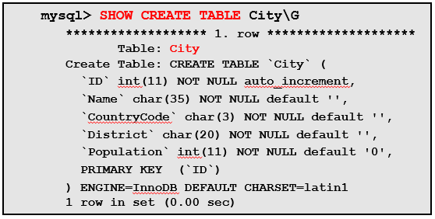

The SHOW CREATE TABLE statement produces a statement that can create a table with the same properties as the table specified. This can help you to understand the structure of a table. You can also use it as a basis for the syntax to create a new table. For example, to show the CREATE TABLE statement used to create the City table, execute the statement shown in the example in the slide.
Column Options
- Each table must have at least one column.
- You can add options to the CREATE TABLE statement, such as:
  - NULL– DEFAULT
  - NOT NULL– AUTO_INCREMENT
- Example:
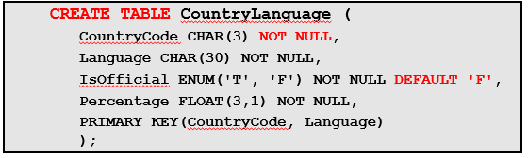
The CREATE TABLE column options modify how MySQL handles the associated column. Some common column options:
- NULL:Is the default option that allows storing of NULL values
- NOT NULL
  - Disallows NULL
  - Saves response time and, in some cases, disk space
  - Is a necessity for a PRIMARY KEY
  - NULL and NOT NULL are mutually exclusive.
- DEFAULT <value>: If no value is supplied by the user, this specified value is stored.
- AUTO_INCREMENT
  - A "running number" option for indexed columns
  - Used for INTEGER data type columns only
  - Using NULL, or not specifying a value for the column, causes an automatic insert of the next available number in sequence
  - Must be indexed
  - Only one permitted per table
Note: Indexes are covered later in this lesson.
Table Options
- You can add options to the CREATE TABLE statement, such as:
  - ENGINE
  - COMMENT
  - DEFAULT CHARACTER SET
- Example:
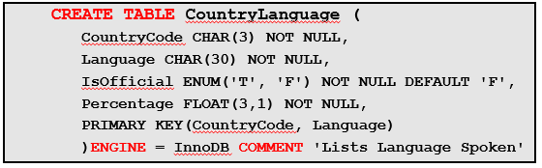
The CREATE TABLEtable options modify how MySQL handles the entire table. Some common table options:
- ENGINE = <storage_engine_name>: Indicates the storage engine to be used for the table
- COMMENT: Up to 60 characters of free form text
- DEFAULT CHARACTER SET <character set>: Specifies the default character set for the table
Table Indexing
- Original table data is not put in any specific order or location.
  - Server must scan all data to find relevant rows.
- Indexes assist in finding rows quickly and easily.
  - Only contain column information for locating rows
- Indexes are assigned when creating a table, or you can add them later.
- Composite indexes are created on multiple columns.
- “Key” is normally a synonym for “index.”
When you insert a row into a table, the database server does not attempt to put the data in any particular location within the table. Instead, the server simply places the data in any available location within the table. Tables can be very large, and as a table gets bigger, retrievals from it become slower. This is due to the fact that the location of the data is unknown, so the server must look at all the data to find the relevant rows.
An index (or key) in MySQL serves to assist in finding rows quickly, like an index at the back of a technical manual. Database indexes are used to locate rows in a table. Instead of containing all of the row data, an index contains only the columns used to locate the rows. It also contains information describing where the rows are physically located. Usually, you create all the indexes you need when you are creating tables.
You can create indexes on single columns or multiple columns (composite indexes). For example, the phone number for an individual in a phone book can be used as a single column index, whereas the last name and first name can be used to create a composite index.
MySQL Indexing
- Commonly used indexes:
  - PRIMARY KEY: Only one allowed
  - UNIQUE: Multiple allowed
- Indexes are optional and must be created by the user.
- Example:
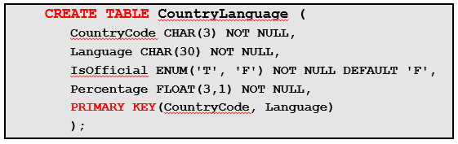
The following are the commonly used indexes:
- PRIMARY KEY
  - Only one PRIMARY KEY is allowed per table.
  - It uniquely identifies a single row in the table.
  - No NULL values are permitted.
  - No duplicate values are permitted.
  - If a duplicate value is INSERT or UPDATE MySQL returns an error and the attempted operation is not performed.
- UNIQUE
  - The same rules as the PRIMARY KEY, with two exceptions:
Can have values stored as NULL
Can have multiple UNIQUE indexes in a table
- Each non-NULL value uniquely identifies a single row in a table.
For more information about how MySQL uses indexes, see the MySQL Reference Manual at http://dev.mysql.com/doc/refman/5.5/en/mysql-indexes.html.
Showing the Table Indexes
- General syntax for displaying table indexes:
- Example:
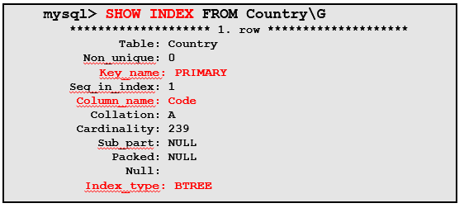
The result of the SHOW INDEX statement example in the slide shows that there is a PRIMARY index on the Code column of the Country table, and an index type of BTREE table. The Cardinality column shows the number of distinct values that exist in the table: 239 in this case.
Note: Most indexes are stored in B-trees. Exceptions are indexes on spatial data types use R-trees, and MEMORY tables also support hash indexes.
For more information about the SHOW INDEX statement, see the MySQL Reference Manual at http://dev.mysql.com/doc/refman/5.5/en/show-index.html.
Table Constraints
- A constraint is a restriction placed on one or more column values of a table to actively enforce integrity rules.
- Constraints are implemented using indexes.
- Types of constraints:
  - PRIMARY KEY
  - FOREIGN KEY
  - UNIQUE
- MySQL generates indexes to enforce the above constraints.

A constraint is a restriction placed on one or more column values of a table to actively enforce integrity rules.
Constraints are implemented using the following indexes:
- PRIMARY KEY: Defines the columns that guarantee uniqueness within a table
- FOREIGN KEY: Restricts the columns to contain only values that match those in another table’s PRIMARY KEY or UNIQUE columns
- UNIQUE: The same as PRIMARY KEY except that the columns are allowed to be null-able, and there may be multiple UNIQUE constraints in one table
For example, if the MySQL server allowed you to modify the world_innodb database by changing the CountryCode value in the CountryLanguage table without changing the corresponding CountryCode value in the City table, then you end up with rows that no longer point to valid country records (known as orphaned rows). With constraints in place (FOREIGN KEY, in this case), the server raises an error if an attempt is made to modify or delete data that is referenced by other tables, or it propagates the changes to other tables for you.
Note: Only the InnoDB storage engine supports FOREIGN KEY constraints. Other storage engines ignore these constraints in table definitions.
DROP DATABASE Statement
- Removes a database when it is no longer needed
  - The database can be empty or contain tables and data.
- Returns a row count, which is the number of tables deleted
- Must be used with extreme caution, because it does not have the “undo” feature
- Examples:
- Returns an error if the database does not exist
  - Returns a warning if the database does not exist
Use DROP DATABASE when you are sure that the database is no longer needed.
You must have the DROP privilege for each database.
DROP DATABASE does not require the database to be empty. Before dropping the database, MySQL removes any objects that it contains, such as tables, stored routines, and triggers.
A successful DROP DATABASE returns a row count that indicates the number of tables dropped. (This actually is the number of .frmfiles removed, which amounts to the same thing.) You can check your current databases to make sure that the database is removed by using the SHOW DATABASES statement.
A database is represented by a directory under the data directory. The server deletes only files and directories that it can identify as having been created by itself (such as .frm files). It does not delete other files and directories. If you have put nontable files in that directory, those files are not deleted by the DROP DATABASE statement. This results in a failure to remove the database directory. In that case, the database continues to be listed by SHOW DATABASES. To correct this problem, you can manually remove the database directory and any files that it contains.
Any warning generated by DROP DATABASE can be displayed with the SHOW WARNINGS statement.
Adding a Table Column
- Use the ALTER TABLE statement with ADD COLUMN.
- Example:
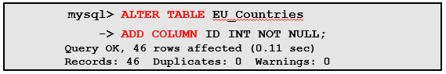
- Changes the structure as follows:
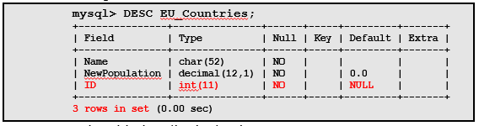
  - ID is added as the last column.
To add a new column (or remove a column), use the ALTER TABLE statement with the appropriate clause that specifies the column’s definition. A column definition uses the same syntax for ALTER TABLE as for CREATE TABLE. You can use ALTER TABLE to:
- Add or remove a column
- Add or remove an index
- Change the specification of a current column
Column names within a table must be unique, so you cannot add a column with the same name as one that already exists in the table. Also, column names are not case-sensitive, so if the table already contains a column named ID, you cannot add a new column using any of these names: ID, id, Id, or iD. They are all considered to be the same.
Adding a Table Column
- Adding a column to a table populates the rows with NULL, the default value as specified, or the data type implicit default.
- In a query, the column appears as empty or zero:
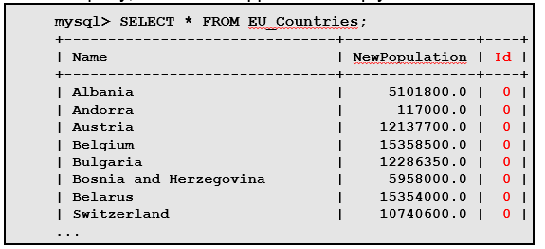
Note: The statement for populating a table with data is covered in detail later in the course.
Removing a Table Column
- Use the ALTER TABLE statement with DROP COLUMN.
- Example:
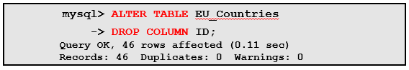
- Changes the structure as follows:
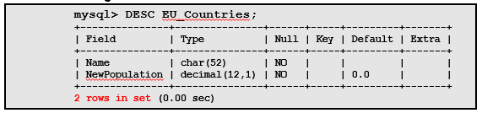
  - The ID column has been removed.
If a table contains only one column, you cannot drop the column. If you intend to remove the table, use DROP TABLE instead.
You should not remove a column from a table if it is a primary key. You cannot remove a column that is a foreign key from another table.
For more information about using ALTER TABLE, see the MySQL Reference Manual at: http://dev.mysql.com/doc/refman/5.5/en/alter-table.html.
Modifying a Table Column
- Use the ALTER TABLE statement with MODIFY COLUMN.
- Example:
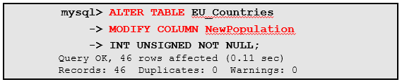
  - Changes the structure as follows:
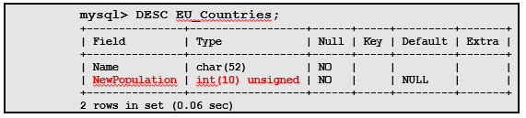
  - NewPopulation has been changed to the INT data type.
The example in the slide shows how you can change the NewPopulation column’s data type from DECIMAL to INT, to restrict the column value to whole numbers. You can also make the UNSIGNED column to disallow negative values.
If you also want to disallow NULL in the column, you must include the NOT NULL attribute in the column definition for MODIFYCOLUMN, even if you originally defined the column with NOT NULL. This is true for other column attributes as well. If you do not specify them explicitly, the new definition does not carry them over from the old definition.
You cannot modify a column from a table if it is a primary key and if a foreign key from another table references the column.
Modifying a Table Column: Row Changes
The previous ALTER TABLE...MODIFY COLUMN statement example changes the row contents of the table as follows:
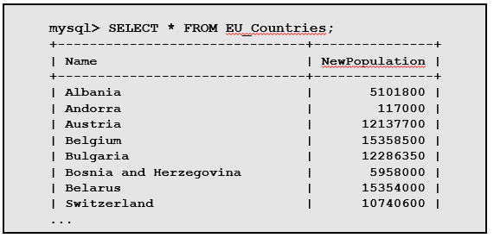
Note: The statement for populating a table with data is covered in detail later in the course.
Anything that can be added using CREATE TABLE can be changed using ALTER TABLE.
For more information about using ALTER TABLE, see the MySQL Reference Manual at: http://dev.mysql.com/doc/refman/5.5/en/alter-table.html.

Truncate a Table
The SQL TRUNCATE TABLE command is used to delete complete data from an existing table.
You can also use DROP TABLE command to delete complete table but it would remove complete table structure form the database and you would need to re-create this table once again if you wish you store some data.
TRUNCATE TABLE EU_Countries;

Truncate command is different from delete command. Delete command will delete all the rows from a table whereas truncate command re-initializes a table(like a newly created table).
For e.g. If you have a table with 10 rows and an auto_increment primary key, if you use delete command to delete all the rows, it will delete all the rows, but will not initialize the primary key, hence if you will insert any row after using delete command, the auto_increment primary key will start from 11. But in case of truncate command, primary key is re-initialized.
Exercise

Consider the following schema:
- Customer (cust_id, cust_name).
- Product (prod_code ,prod_name, unit_price)
- Customer_Order (order_code, order_date, cust_id)
- Order_Item (order_code, prod_code, num_of_units)

- Develop DDL of in SQL
- Add Column contact in Customer Table
- Add Column company_name in Product Table

Feedback

LAB # 06

The Purpose of this Lab is to introduce the DML (Data Manipulation Language) which includes Insert, Update & Delete Statements

Name
Date
Registration No
Department
Quiz
Assignment

___________________
Lab Instructor Signature

Introduction to DML Experiment
06
Objective

The Purpose of this Lab is to introduce the DML (Data Manipulation Language) which includes Insert, Update & Delete Statements
Theory

Data Manipulation Language: SQL Statements
The DML SQL statements are used to manipulate database and table data. The statements shown in the slide are followed by options to specify data operations (such as table name).
Manipulation of Table Row Data
- It is common for databases to require modification:
  - This is due to changes in data usage situations.
  - Row data can be inserted, updated, replaced, or deleted.
Data manipulation can be unsafe. Take the following precautions with your data:
  - Do not grant users (including yourself) more permissions than required. For example, if you are running some ad hoc queries on a database for the finance department, do not use the MySQL root account. Instead, create a user who has permission to run only the needed SELECT queries and then log in as the user.
  - Keep daily backups of the data stored in MySQL.
  - Always make a backup before you make any major changes, or when using unfamiliar features.
  - For beginners, a useful startup option is the safe updates option. It can be turned on with the command-line client option --safe-updates, or by issuing SET SQL_SAFE_UPDATES=1. It is helpful for cases when you might have issued a DELETE FROM tbl_name statement but forgotten the WHERE clause. Normally, such a statement deletes all rows from the table. With this option, you can delete rows only by specifying the key values that identify them. This helps prevent accidents.
  - Test queries and updates on a test table before running them on the real table.
  - Execute a SELECT statement with the same WHERE clause to verify that the right results are returned, before running a DELETE or an UPDATE statement.
INSERT Statement
- After creating a table, you can populate it with row data.
- General syntax includes the INTO clause:

- Example of inserting a singlerow:

  - The content of the new row:
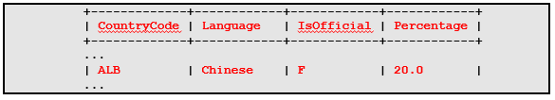
The syntax for INSERT uses separate column and value lists following the name of the table into which you add the single record. The number of columns and values must be the same.
In the INSERT example in the slide, you add Chinese as a language for Albania, with a percentage of 20, and the default F (false) for the IsOfficial column is acceptable because it is not the official language of the country.
In the result for the example in the slide, the false (F) value for the IsOfficial column is the default value, which is used in the absence of a specific assignment.
Using INSERT for Multiple Rows
- Create multiple new rows in a table.
- Example:
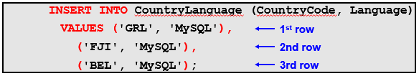
  - The content of the new row:
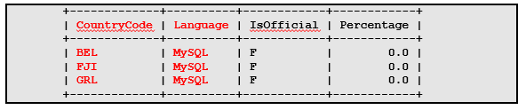
In the INSERT example in the slide, you add MySQL as a language for Greenland, Fiji, and Belgium. However, you do not want to give it a percentage, and the default F (false) for the IsOfficial column is acceptable. The row data for each of the three rows is enclosed in parentheses.
The result for the example in the slide is achieved with the following query:
SELECT * FROM CountryLanguage
WHERE CountryCode IN ('GRL', 'FJI', 'BEL')
AND LANGUAGE = 'MYSQL';
In the example result in the slide, the F (false) value for the IsOfficial column is the default value, which is used in the absence of a specific assignment.
Note: You must enclose all column values in single quotation marks (for string and temporal data types) in the INSERT statement.
NULL condition with INSERT
If values are not specified and columns have no default value:
- Sets to NULL if column accepts NULL values
- Sets to implicit default for the column data type if it does not accept NULL
- AUTO_INCREMENT columns automatically generate the next sequence number
UPDATE Statement
- Modifies contents of existing rows
- Is used with the SET clause for column assignments
- General syntax:

- Example:
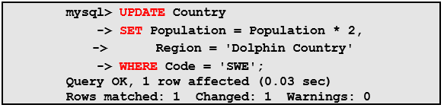
The example in the slide demonstrates how you can update the Country database by changing the Population column calculation and the Region to Dolphin Country for the country Sweden (code 'SWE'). The results show one row affected, one row matched (selected by the WHERE clause), and one row changed.
UPDATE Statement Ordering
- There is no guarantee about the order in which rows are updated, which can result in errors:
- Use ORDER BY to control the order:
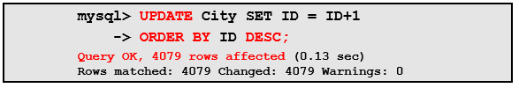
  - The content of the new row:
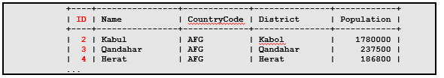
To solve the problem of the first UPDATE in the slide that causes an error, add an ORDERBY clause to cause the row updates to occur in a particular order, as shown in the second UPDATE.

The results shown in the slide are a result of the following query:
mysql> SELECT * FROM City ORDER BY ID;
+------+----------------+-------------+---------------+------------+
| ID | Name | CountryCode | District | Population |
+------+----------------+-------------+---------------+------------+
| 2 | Kabul | AFG | Kabol | 1780000 |
| 3 | Qandahar | AFG | Qandahar | 237500 |
| 4 | Herat | AFG | Herat | 186800 |
| 5 | Mazar-e-Sharif | AFG | Balkh | 127800 |
| 6 | Amsterdam | NLD | Noord-Holland | 731200 |
...
| 4079 | Nablus | PSE | Nablus | 100231 |
| 4080 | Rafah | PSE | Rafah | 92020 |
+------+----------------+-------------+---------------+------------+
4079 rows in set (0.02 sec)
Note: The IDs start at the number 2, due to the update.

DELETE Statement
- Use DELETE to remove whole, specified table rows instead of individual columns
- General syntax:
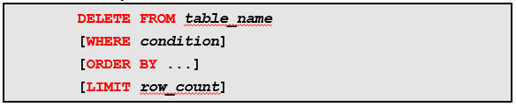
    - Use WHERE to indicate which rows to remove.

- Indicate table name only to remove all table rows:
- Use DELETE with extreme caution, because it does not have the “undo” feature.
The DELETE result indicates the number of rows affected, which can be zero (0) if the statement did not cause a change to be made.
Exercise

Question 1
Insert the following data into the following table
Movie (id, title, year, director)
Id | Title | Year | Director
1 | Ben hur | 2016 | Thomas
2 | Get Smart | 2012 | Richard Bell
3 | Spider Man | 2009 | Tam Morry
4 | Batman V/S Super Man | 2015 | Gerald Hond

Feedback

LAB # 07

The Purpose of this Lab is to introduce the DCL (Data Control Language) which includes Grant & Revoke Statements

Name
Date
Registration No
Department
Quiz
Assignment

___________________
Lab Instructor Signature

Introduction to DCL Experiment
07
Objective

The Purpose of this Lab is to introduce the DCL (Data Control Language) which includes Grant & Revoke Statements
Theory

Data Control Language (DCL) is used to control privilege in Database. To perform any operation in the database, such as for creating tables, sequences or views we need privileges. Privileges are of two types,
- System: creating session, table etc are all types of system privilege.
- Object: any command or query to work on tables comes under object privilege.
DCL defines two commands,
- Grant: Gives user access privileges to database.
- Revoke: Take back permissions from user.

To Allow a User to create Session
grant create session to username;

To Allow a User to create Table
grant create table to username;

To provide User with some Space on Table space to store Table
alter user username quota unlimited on system;

To Grant all privilege to a User
Grant sysdba to username

To Grant permission to Create any Table
Grant create any table to username

To Grant permission to Drop any Table
Grant drop any table to username

To take back Permissions
revoke create table from username
Exercise

Question 1
Grant all privilege to user which name Ali.
Question 2
Grant only creates permission to user which name Fahad.

Feedback

LAB # 08

The Purpose of this Lab is to get familiar with basic Select Queries which includes Selection & Projection Queries & Some Built-in Functions

Name
Date
Registration No
Department
Quiz
Assignment

___________________
Lab Instructor Signature

Select Queries (Selection, Projection, Functions) Experiment
08
Objective

The Purpose of this Lab is to get familiar with basic Select Queries which includes Selection & Projection Queries & Some Built-in Functions
Theory

SELECT Statement
- SELECT is the most commonly used DML command for queries:
  - Retrieves rows from tables in a database
  - Returns rows as a “result set” in the form of a table
- General syntax:

- column_list is a list of column names that make up the result set.
  - Separate the items in the list with a comma separator (,).

SELECT is the most commonly used data manipulation language (DML) statement. The SELECT statement forms a description of the data that is to be retrieved from the database. It does not specify exactly how the data is to be retrieved. The result returned by the database server in response to a SELECT statement takes the form of a table, which is a collection of rows.
An expression that does not contain any column name is allowed in <column_list>.

We have a database name boat_reservation:
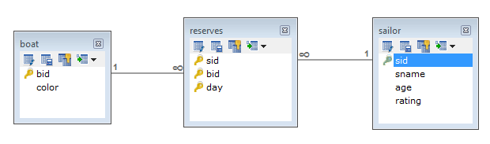
- sailor have id, name , age & rating.
- boat have id & color.
- Sailor can reserves multiple boats.
- Boat can be reserve by multiple sailors.
- So, There is a many-to-many relationship between sailor & boat.
- We Resolve this by Introducing new Relation name reserves.
SELECT example:
mysql> SELECT sname , rating FROM sailor
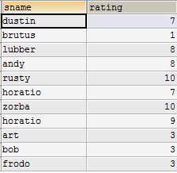
Projection: Deletes unwanted columns from relation.
Projection, which retrieves all the rows in the Name and Rating columns from the Sailor table. Queries can be performed on one, multiple, or all columns, on one or more tables.
For example, you can retrieve all the column data from the Sailor table, using (*):
mysql> SELECT * FROM sailor
Note: The word “query” is most commonly used to describe a SELECT statement.
Using SELECT Clauses
Optional clauses can be used alone (or in combination) to generate specific query results.
- Types of clauses:
  - DISTINCT: Eliminates duplicate rows from the result set
  - FROM: Specifies what tables to retrieve data from
  - WHERE: Filters for specific rows
  - ORDER BY: Sorts rows by specified order
- Syntax example (with the order of the clauses fixed):
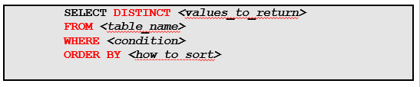
The syntax example in the slide shows the correct order and usage of each of the listed optional clauses. This statement performs the following:
- Specifically selecting DISTINCT rows
- FROM a named table
- WHERE some condition defines which rows to return
- Given a specific sorting order (ORDER BY)
The order of the clauses is fixed. Therefore, if you do not keep them in their proper order, you get a syntax error. No result set is returned.
Using SELECT with DISTINCT
- Removes duplicate rows, so every result set row is unique
- Example of difference between SELECT without and with DISTINCT:

Without DISTINCT
mysql>SELECT rating FROM sailor
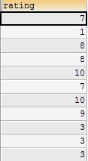

With DISTINCT
mysql>SELECT DISTINCT rating FROM sailor
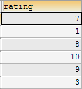
SELECT with WHERE
Selection: Selects a subset of rows from relation.
Subset of Relation can be obtained using Some Condition (or Using Where Clause)
Expressions in a WHERE clause can use the following types of operators:
- Arithmetic:+, -, *, /, DIV, %
- Comparison:<, <=, =, <=>, <> or !=, >=, >, BETWEEN
- Logical: AND, OR, XOR, NOT
- Additional options: IN, IS NULL, LIKE, ()
Arithmetic Operators
Perform mathematical operations on column value expressions:
- + Addition
- - Subtraction
- * Multiplication
- / Division
- DIV Integer division
- % Modulo (remainder after division)
Comparison Operators
Compare column value expressions
- + Addition
- < Less than
- <= Less than or equal to
- = Equal to
- <=> Equal to (works even for NULL values)
- <> or != Not equal to
- >= Greater than or equal to
- > Greater than
- BETWEEN <value1> AND <value2>Indicate a range of values (inclusive)

Logical Operators
Combine Boolean expressions
- AND: Logical AND
- OR: Logical OR
- XOR: Logical exclusive-OR
- NOT: Logical negation
Additional options in a WHERE condition:
- IN is equivalent to a list of comparisons with OR, but more readable and efficient.
- You can use IS NULL to check whether a value is null (such as ... <column_name> IS NULL).
- The LIKE operator can be used for pattern matching (such as WHERE <value>LIKE '<pattern>').
- You can also use parentheses (<expression>) to group parts of an expression.
- Operators can be applied to almost all types of value expressions such as literals, columns, function calls, and so on.
- You can also combine several criteria with logical operators.
SELECT with WHERE
Example of WHERE with IN:
mysql> SELECT sid, sname , age
FROM sailor
WHERE age IN (26,45,35)
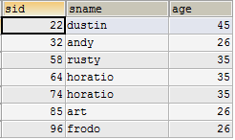
SELECT with WHERE
Example of WHERE with AND and OR:
mysql> SELECT sid, sname, rating
FROM sailor
WHERE age>30 AND (rating = 3 OR rating = 8)
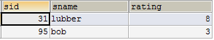

SELECT with ORDER BY
- Returns output rows in a specific order
- Example of ORDER BY:

mysql> SELECT sname
FROM sailor
ORDER BY sname
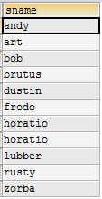
By default, the server returns the rows in the SELECT statement to the client in no particular order. When you issue a query, the server is free to return the rows in any convenient order. This order can be affected by factors such as the order in which the rows are actually stored in the table, or which indexes are used to process the query. If you require output rows to be returned in a specific order, include an ORDER BY clause that indicates how to sort the results.
The example in the slide sorts the names of the countries in alphabetical order by sname, from the sailor table.
Previous Example With ORDER By Clause:
mysql> SELECT sid , sname, rating
FROM sailor
WHERE age>30 AND (rating = 3 OR rating = 8)
ORDER BY sname
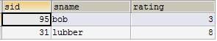
SELECT with ORDER BY with ASC and DESC
- Specify order with ASC and DESC
    - ASC: Ascending order (default)
    - DESC: Descending order
- Example of ORDER BY with DESC:
mysql> SELECT sname
FROM sailor
ORDER BY sname DESC
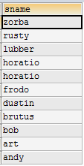
Ascending order is the default sort order in an ORDER BY clause. You can specify explicitly whether to sort a column in ascending or descending order by using the ASC or DESC keywords after the column names. Ascending means that the lowest value comes first.
Functions
MySQL Expressions
- Functions can be invoked within expressions.
- An expression returns a value that is used in place of the function call when evaluated.
- General syntax:
  - The parentheses following the function name are required.
- Examples:
  - SELECT NOW(): The NOW function returns the current date and time.
  - SELECT VERSION(): The VERSION function returns the MySQL server version currently being used on the host.
In the general syntax, a function call includes the function name followed by parentheses (which may contain arguments used to perform the function).

String Functions
String Function: Numeric Category Examples
- Returns the number of characters in the string:
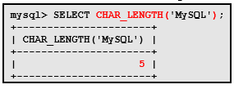
- Returns the position in the string where substring occurs:
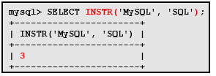
String Function: String Category Examples (CONCAT, REVERSE, LEFT, RIGHT)
- Concatenates the given arguments into one string:
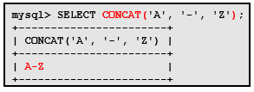
- Returns string with the characters in reverse order:
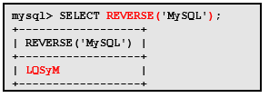
- Returns the left-most length characters of string:
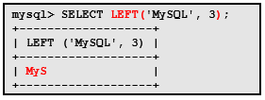
- Returns the right-most length characters of string:
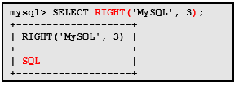
- Returns the part of the string starting at the specified position through the end of string:
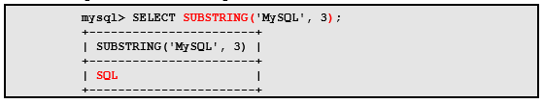

- Returns the part of the string starting at the specified position, and the number of characters indicated:
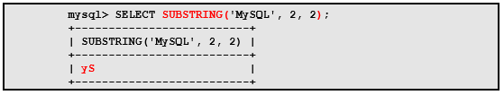
Temporal Functions: Date/Time Formats
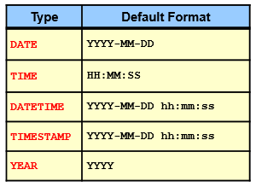
The Date/Time formats chart in the slide gives a list of all date and time formats permitted to be used within temporal functions.
See the Data Types lesson for specific information about the values and ranges for these format types.
Functions that expect date values usually accept DATETIME values and ignore the time part. Functions that expect time values usually accept DATETIME values and ignore the date part.

Temporal Functions: Function Types
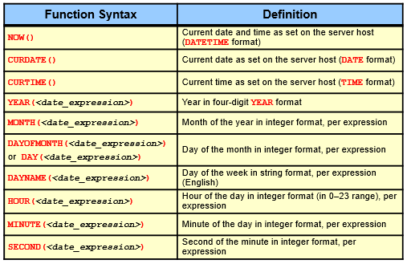

Temporal Functions: Extracting Temporal Data Examples
- Extracting current temporal data (date, time, and day of week):
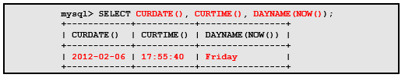
- Addition of a specified interval of days from the current date and time:
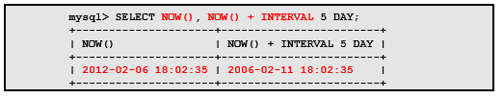
Temporal Functions: Extracting Temporal Data Examples
- Customizing the output format of temporal data:
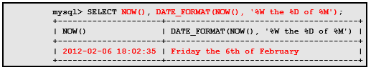
Syntax and additional information for the temporal functions:
- DATE_FORMAT (<date>, <format>)
- The %symbol is required before any predefined date/time format specifiers.
Numeric Functions
Perform mathematical operations such as:
- Rounding
- Truncation
- Trigonometric calculations
- Generating random numbers
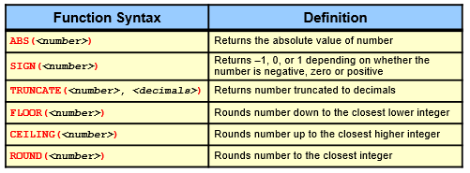
ROUND (<number>):
- Rounds up on DECIMAL data types
- Defaults to zero, if not specified
- For exact-value numbers, a value with a fractional part less than .5 is rounded down to the next integer if positive, or up to the next integer if negative.
- For approximate-value numbers, the result depends on the C library. On many systems, this means that a value with any fractional part is rounded to the nearest even integer.

Numeric Functions: Examples
- Returns the absolute value of the negative and positive values:
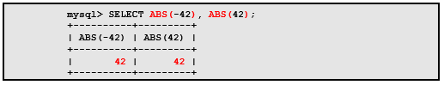
- Returns results of sign determination (–1=negative, 0=zero, 1=positive):
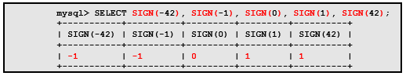
Numeric Functions: Additional Functions
- Geometric functions:
  - DEGREES(), PI(), RADIANS()
- Trigonometric functions:
  - COS(), SIN(), COT()
  - ACOS(), ASIN(), ATAN(), ATAN2()
- Other functions:
  - EXP(), LN(), LOG(), LOG2(), LOG10()
  - POWER(), SQRT()
  - MOD()

Exercise

Emp_num | Emp_Name | Emp_Job | Emp_Sal
E101 | Salman | Analyst | 6000
E102 | Bushra | Programmer | 5000
E103 | Madiha | Web Designer | 6000
E104 | Aiman | ERD designer | 4000
E105 | Hameed | Web Designer | 3000
E106 | Nini | Analyst | 2500
E107 | Imtiaz | Web Designer | 6500
E108 | Rashid | Programmer | 4000
E109 | Muzzamil | ERD designer | 2000

- List all employees’ number, employee’s name and jobs from emp.

- List all employees’ number, employee’s name and jobs from emp whose salaries greater than 5,000.

- List all employees’ number, employee’s name and jobs from emp whose salaries less than 5,000.

- List all employees’ number, employee’s name and jobs from emp whose salaries between 1,000 to 5,000.

- List all employees’ number, employee’s name, jobs and salaries from emp.

Feedback

LAB # 09

The Purpose of this Lab is to get familiar the Tables Joins Which Includes Inner, Outer & Natural Joins

Name
Date
Registration No
Department
Quiz
Assignment

___________________
Lab Instructor Signature

Select Queries (Join Types: Inner, Outer, Natural) Experiment
09
Objective

The Purpose of this Lab is to get familiar the Tables Joins Which Includes Inner, Outer & Natural Joins
Theory

Combining Multiple Tables
- Some questions cannot be answered using just one table.
- Some queries require SELECT statements that include a combination of multiple tables.
- A join operation is used to combine the data from one table with the data of another table.
The SELECT queries shown so far in this course retrieve data from a single table at a time. This lesson addresses the performance of multiple table queries.
If you want to find the details of records referenced in a foreign key, you combine data from two or more tables by performing a table join.
Joining Tables with SELECT
- Example of two separate tables that can be joined:
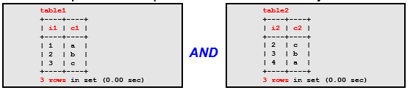

- Joined tables:
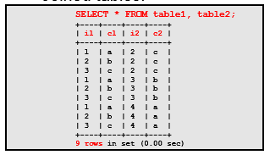
  - This join results in a Cartesian product.
  - The result includes all combinations of rows from table1 and table2.
When you cross-join two tables (as in the example in the slide), each row from one table is combined with each row from every other table, yielding all possible combinations of rows. This result is also known as the Cartesian product. Joining tables this way has the potential to produce a very large number of rows because the row count is the product of the number of rows in each table.
A cross-join between two tables each containing 1000 rows will return 1000 × 1000 = 1 million rows. That is a lot of rows, even though the individual tables are small. Such a join is also called an unqualified join.
Categories of Joins
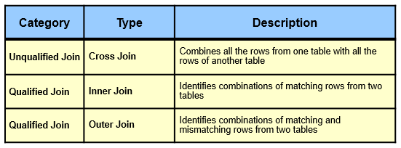
- Unqualified join: Retains all row pairs
- Qualified join: Retains only specific row pairs according to a particular join condition
The large majority of joins are qualified. Most qualified joins serve to combine related tables.

INNER JOIN Keywords
- INNER JOIN replaces the comma separator.
  - Can be used with the ON or USING clause
- Examples:
Find the names of those sailor who reserved the boat.
mysql> SELECT s.sname  FROM sailor s INNER JOIN reserves r  ON s.sid = r.sid | 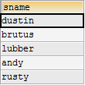
mysql> SELECT s.sname
FROM sailor s INNER JOIN reserves r
USING(sid)

The syntax discussed earlier uses the comma separator in the FROM clause to name (and separate) the joined tables. Another inner join syntax uses the INNER JOIN keywords. With this syntax, those keywords replace the comma separator between table names. Also with INNER JOIN, the conditions that indicate how to perform row matching for the tables move from the WHERE clause to become part of the FROM clause.
The ON or USING clause conditions indicate how to perform the join.
Note: ON and USING are not exactly identical. USING treats the columns from the two tables as the same, whereas ON treats them as two different columns.
JOIN Keywords
- JOIN is equivalent to INNER JOIN.
  - Can be used with the ON and WHERE clauses
- Example: Find the names of those sailor who reserved boat no. 103.
mysql> SELECT s.sname
FROM sailor s JOIN reserves r
ON s.sid = r.sid
WHERE r.bid=103
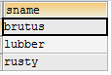
Note: The INNER JOIN keywords are equivalent to the JOIN keyword, and they can be used interchangeably.

Outer Joins
- Identify combinations of matching and mismatching rows from two tables
- Can use two different types of SELECT query syntax:
  - LEFT JOIN: Uses the table to the left of the keywords to base the join comparison on
  - RIGHT JOIN: Uses the table to the right of the keywords to base the join comparison on

You do not get mismatches as you would with a cross-join.
The LEFT JOIN and RIGHT JOIN answer the same kinds of questions, but differ slightly in their syntax. A LEFT JOIN can always be rewritten into an equivalent RIGHT JOIN.
LEFT JOIN Keywords
mysql> SELECT s.sname, r.bid
FROM sailor s LEFT JOIN reserves r
ON s.sid = r.sid
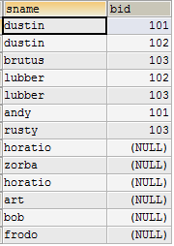
In the above example, the LEFT JOIN results in a list that shows where there were NULLs for those sailor who were not reserved any boat:
RIGHT JOIN Keywords
mysql> SELECT s.sname, r.bid
FROM reserves r RIGHT JOIN sailor s
ON r.sid = s.sid
In the above example, the RIGHT JOIN results in a list that shows where there were NULLs for those sailor who were not reserved any boat:
Natural Join
- The associated tables have one or more pairs of identically named columns.
- The columns must be the same data type.
- Don’t use ON clause in a NATURAL JOIN.
- Example
mysql> SELECT s.sname
FROM sailor s NATURAL JOIN reserves r
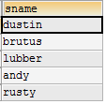
Exercise

Question No. 1
We have the following tables which creates statement are
- create table supplier(S_NO int identity(1,1), SUP_ID varchar(50) primary key,SUP_NAME varchar (50), SUP_ADD varchar (50), SUP_NIC int, rank int)
- create table Product(Prod_ID varchar(50) primary key,Prod_Name varchar(50),[Price/Unit] float)
- create table Orders(Ord_ID varchar(50) primary key,Prod_ID varchar(50),Qty int,Totalrate int,SUP_ID varchar (50))
Write the Queries using Joins on above tables
- List of all supplier that palced order
- List of all Product that are supplied by supplier whose id is 101
- Find all order(s) of product named Rice

Feedback

LAB # 10

The Purpose of this Lab is to get familiar that how to use Groups & Having Clauses with Aggregates Functions

Name
Date
Registration No
Department
Quiz
Assignment

___________________
Lab Instructor Signature

Select Queries (Aggregates, Groups, Having) Experiment
10
Objective

The Purpose of this Lab is to get familiar that how to use Groups & Having Clauses with Aggregates Functions
Theory

Aggregate Functions
- Perform summary operations on a set of values, such as:
  - Counting
  - Averaging
  - Finding minimum or maximum values
- Calculate a single value based on a group of values from different rows.
- Result value is based only on non-NULL values from the selected rows.
Aggregate functions are also known as group functions. A SELECT statement can produce a list of rows that match a given set of conditions. This list provides the details about the selected rows. However, if you want to know about the overall characteristics of the rows, you are more interested in getting a summary instead. The resulting value is based only on non-NULL values from the selected rows (with the exception that COUNT(*) counts all rows).
Some of the aggregate function types:
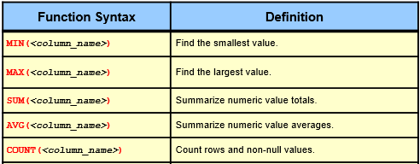
All the functions can use the DISTINCT keyword, although it is not useful for the MAX() and MIN() functions.
DISTINCT examples:
SUM(DISTINCT <column_name>)
AVG(DISTINCT <column_name>)
COUNT(DISTINCT <column_name>)
Aggregate Functions: COUNT Function Examples
mysql>SELECT COUNT(*) FROM reserves
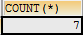
mysql>SELECT COUNT(sid) FROM reserves
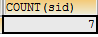
mysql> SELECT COUNT(DISTINCT sid) FROM reserves
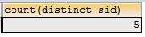
Aggregate Functions: SUM Function Example
mysql> SELECT SUM(sid) FROM reserves
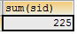
Aggregate Functions: AVG Function Example
mysql>SELECT AVG(sid) FROM reserves
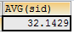

mysql> SELECT AVG(rating) FROM sailor
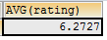

Aggregate Functions: MIN Function Example
mysql> SELECT MIN(rating) FROM sailor
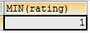
Aggregate Functions: MAX Function Example
mysql> SELECT MAX(rating) FROM sailor
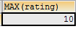

GROUP BY
- The GROUP BY clause places rows into groups.
  - Each group consists of rows having the same value in one or more columns.
  - Calculates a summary value for each group
- General Syntax:
SELECT [DISTINCT] target-list
FROM relation-list
WHERE qualification
GROUP BY grouping-list
- Example:
mysql> SELECT rating, COUNT(sid)
FROM sailor
GROUP BY rating
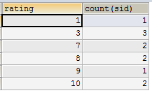

In above Example, group is make on rating column and count the no. of sailor for each rating.
Find no. of sailor for each rating in which sailor age must be greater than 25
mysql> SELECT rating, COUNT(sid)
FROM sailor
WHERE age>25
GROUP BY rating
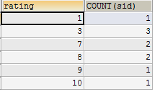
HAVING
- Use the HAVING clause to eliminate rows based on aggregate values.
  - Evaluated after the grouping implied by GROUP BY
- General Syntax:
SELECT [DISTINCT] target-list
FROM relation-list
WHERE qualification
GROUP BY grouping-list
HAVING group-qualification
- Example
mysql> SELECT rating, COUNT(sid)
FROM sailor
GROUP BY rating
HAVING COUNT(sid)>1
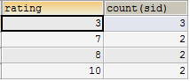
In above Example, group is make on rating column and count the no. of sailor for each rating which rating have minimum sailor count is 2.
You can use the HAVING modifier to require that the groups produced by a GROUP BY clause satisfy particular criteria.
As such, it resembles the WHERE clause. The difference is that the HAVING clause is evaluated after the grouping implied by the GROUP BY clause. This means that the HAVING condition can refer to aggregate functions. However, any part of a condition that can also appear in the WHERE clause should not be in the HAVING clause. A good HAVING clause is always based on aggregate functions (because these are not allowed in the WHERE clause).

Exercise

Question No. 1
- List average salary of each job.
- Find average and sum of all the salaries of each job excluding clerks.
- Find average and sum of the salaries of each job excluding salesmen', clerk' and 'manager'.
- Find count, sum and average salaries of each job excluding salesmen', clerk' and 'manager'.
- List average salary of each department.

Feedback

LAB # 11

The Purpose of this Lab is to get familiar with the Analytical Queries Which includes Rollup, Cube & Top- N (Limits) Queries

Name
Date
Registration No
Department
Quiz
Assignment

___________________
Lab Instructor Signature

Analytical Queries (Rollup, Cube) Experiment
11
Objective

The Purpose of this Lab is to get familiar with the Analytical Queries Which includes Rollup, Cube & Top- N (Limits) Queries
Theory

The ROLLUP operator is useful in generating reports that contain subtotals and totals. The ROLLUP operator generates a result set that is similar to the result sets generated by the CUBE operator.
ROLLUP
- ROLLUP generates a result set that shows aggregates for a hierarchy of values in the selected columns.
- General Syntax:
SELECT [DISTINCT] target-list
FROM relation-list
WHERE qualification
GROUP BY grouping-list
WITH ROLLUP
- Example:
mysql> SELECT rating, age, COUNT(sid)
FROM sailor
WHERE age>25
GROUP BY rating, age
WITH ROLLUP
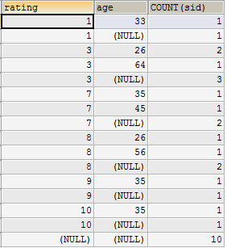
CUBE
- CUBE generates a result set that shows aggregates for all combinations of values in the selected columns.

LIMIT
- Specifies the number of rows to output in result set
- Example without LIMIT:
mysql> SELECT bid, COUNT(sid)
FROM reserves
GROUP BY bid
ORDER BY bid DESC
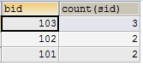

- Example with LIMIT
mysql> SELECT bid, COUNT(sid)
FROM reserves
GROUP BY bid
ORDER BY bid DESC
LIMIT 1
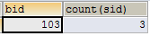

Exercise

Question No. 1
- Find the names of Top 10 employees which salaries are highest.

Feedback

LAB # 12

The Purpose of this Lab is to get familiar with the concept of Normalization

Name
Date
Registration No
Department
Quiz
Assignment

___________________
Lab Instructor Signature

Normalization - Introduction Experiment
12
Objective

The Purpose of this Lab is to get familiar with the concept of Normalization
Theory

Normalization
Normalization is the process of refining a relational database design to ensure that each independent piece of information is in only one place.
- Eliminates redundant data
- Eliminates modifications that make the data inconsistent
- “Decomposes” database into a set of smaller tables
- Removes multi-valued attributes and repeating groups
- Facilitates good database design

Advantages of Normalization
- ERDs:
  - Enables you to develop diagrams effortlessly when tables, columns, and relationships are predetermined
- Updates:
  - Avoid anomalies such as insertion, deletion, and modification problems, which cause inconsistencies with updates
- Compact:
  - Modifies a single object property easily

- Data access:
  - Enables you to access all logically required data
- Joins:
  - Identify the join columns
Minimize the amount of data having to be searched
Disadvantages of Normalization
Despite the numerous advantages of normalization, there are some disadvantages to be considered:
- Several tables:
  - Must be accessed for user reports and other user data
- Maintenance:
  - Can be in some conflict with the business processes. For example, you may have to duplicate information or create summary tables to gain more speed, due to the maintenance costs of keeping multiple copies of data.
- Resource usage:
  - Can be an expensive process in time and resources
  - Takes many join statements to get the required data

Eliminating Data Inconsistencies
Eliminating insertion, deletion, and modification anomalies is a key advantage to normalization.
- Poorly designed table structures result in duplicate data, redundant data, and difficulties in using the data.
- To avoid anomalies, ensure that each table column meets the following criteria:
  - Represents a characteristic of the table subject
  - Contains only a single value
  - Is not deconstructed into smaller components
  - Does not contain a calculated or concatenated value
  - Is unique within the entire database structure
  - Multi-table columns (in relationship) are identical

Normal Forms
- Many successive levels (called normal forms) of normalization guarantee consistency.
- Each consecutive normal form depends on the previous.
- The first three levels are the most common (from 1NF to 2NF to 3NF)
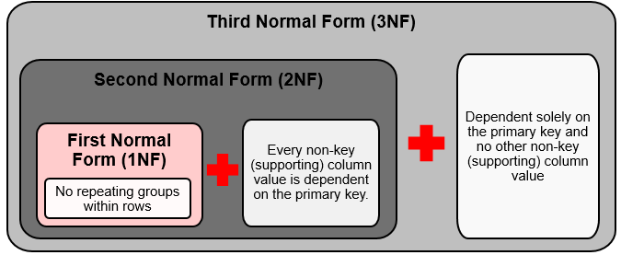
Normalization Process: Example
The normalization process is demonstrated by using a very simple example:
Assume a video library maintains a database of movies rented out. Without any normalization all information is stored in one table as shown below.
- You want to turn spreadsheet into a database, so you can:
- Execute intelligent searches
- Make modifications
- Prepare for future growth of your business
Original spreadsheet
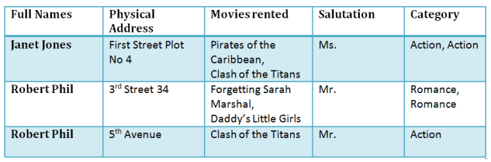

1NF Example
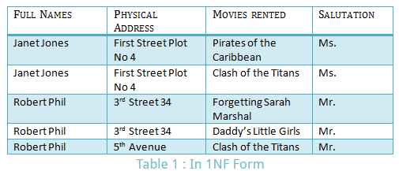
2NF Example
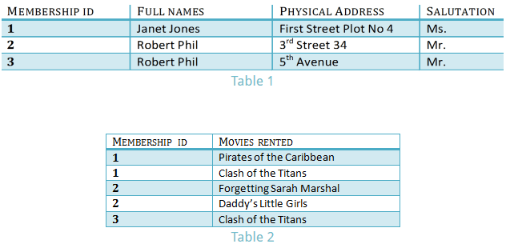

3NF Example
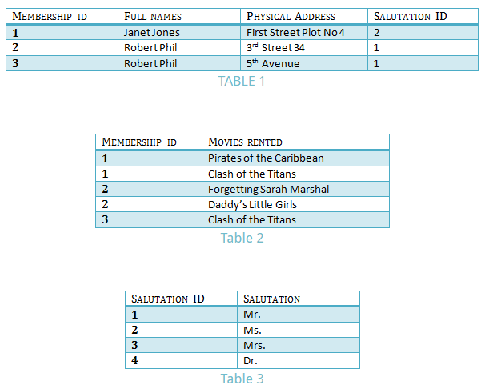

Exercise

HEALTH HISTORY REPORT
PET ID PET NAME PET TYPE PET AGE OWNER VISIT DATE PROCEDURE
246 ROVER DOG 12 SAM COOK JAN 13/2002 01 - RABIES VACCINATION
MAR 27/2002 10 - EXAMINE and TREAT WOUND
APR 02/2002 05 - HEART WORM TEST

298 SPOT DOG 2 TERRY KIM JAN 21/2002 08 - TETANUS VACCINATION
MAR 10/2002 05 - HEART WORM TEST

341 MORRIS CAT 4 SAM COOK JAN 23/2001 01 - RABIES VACCINATION
JAN 13/2002 01 - RABIES VACCINATION

519 TWEEDY BIRD 2 TERRY KIM APR 30/2002 20 - ANNUAL CHECK UP
APR 30/2002 12 - EYE WASH

- Normalize above health report to 1-NF
- Also Normalize From 1-NF to 2-NF
- Also Normalize From 2-NF to 3-NF

Feedback

LAB # 13

The Purpose of this Lab is to make Normalized ERD – by using Case Studies

Name
Date
Registration No
Department
Quiz
Assignment

___________________
Lab Instructor Signature

Normalization – Case Study Experiment
13
Objective

The Purpose of this Lab is to make Normalized ERD – by using Case Studies
Theory

CASE - STUDY
The normalization process is demonstrated by using a very simple example:
- Furniture store
  - You want to turn your inventory spreadsheet into a database, so you can:
    - Execute intelligent searches
    - Make modifications
    - Prepare for future growth of your business
Original inventory spreadsheet
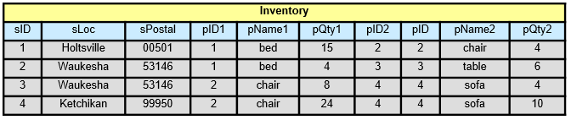

First Normal Form: 1NF
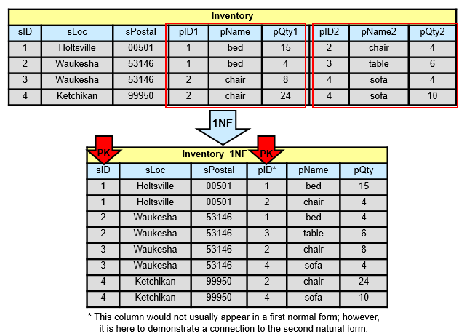

Second Normal Form: 2NF
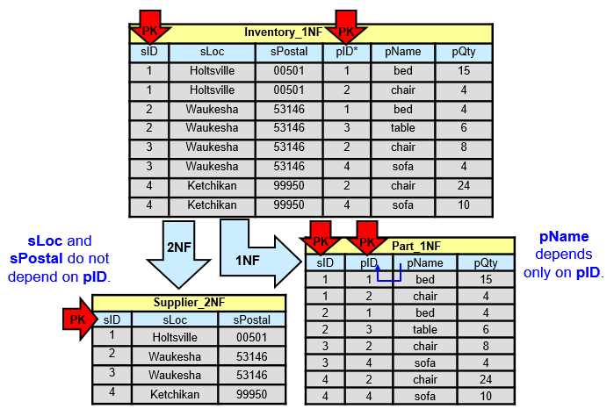

Third Normal Form: 2NF
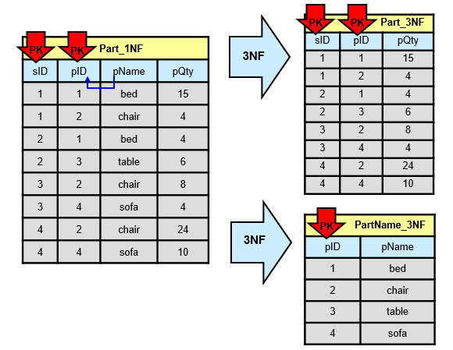

Third Normal Form: 3NF
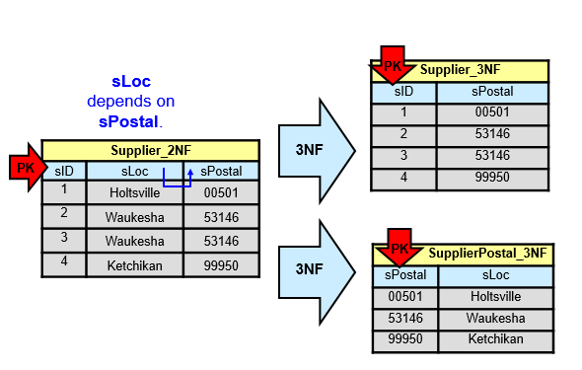
Normalized “Furniture Store” Database

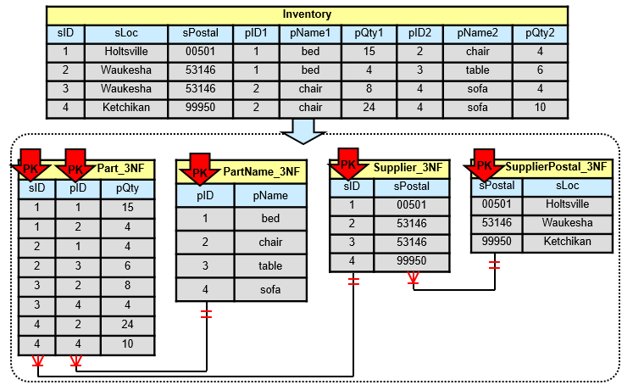
Exercise

CASE - STUDY
We have an Un-Normalized data of Project Management System. Transform this into the Normalized Forms.
- 1NF - No Repeating Groups Within the Row
- 2NF - Every non-key column value is dependent on the Primary Key
- 3NF - Dependent Solely on the primary key and no other non-key (supporting) column value
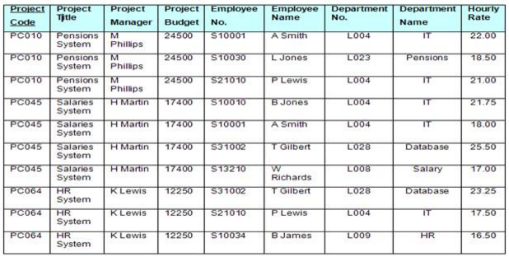

Feedback

LAB # 14

The Purpose of this Lab is to get familiar that how to use SQL Stored Procedures with One Parameter & Multiple Parameters

Name
Date
Registration No
Department
Quiz
Assignment

___________________
Lab Instructor Signature

SQL Stored Procedures Experiment
14
Objective

The Purpose of this Lab is to get faith the Database Administration that how we Install,

The Purpose of this Lab is to get familiar that how to use SQL Stored Procedures with One Parameter & Multiple Parameters
Theory

Stored Procedure
A stored procedure in SQL is a type of code in SQL that can be stored for later use and can be used many times. So, whenever you need to execute the query, instead of calling it you can just call stored procedure .Values can be passed through stored procedures. You can also pass parameters to a stored procedure, so that the stored procedure can act based on the parameter value(s) that is passed.

Create a Stored Procedure
SQL stored procedure general syntax:
CREATE PROCEDURE procedure_name
AS
Sql_statement
GO;

Execute Stored procedure syntax

EXEC procedure_name;
- Below is given the database

Customer_ID | CustomerName | Country | ContactName | Address | City | Postal code
1 | Ram | India | Sita | 78 sudama nagar | Indore | 452001
2 | Sam | Mexico | Rose | Avda de la Constitución 2222 | México D.F. | 05021
3 | Antonio | Mexico | Moreno | Matadero 2312 | Mexico D.F. | 05023
4 | Wendy | UK | Thomas | 120 Hanover Sq. | London | WA1DP
5 | Berglund | Sweden | Christina | Berguvsvägen8 | Lulea | S- 95822

Example of Stored Procedure in SQL
The following statements create a stored procedure and help select all records
mysql>CREATE PROCEDURE SelectAllCustomers
AS
SELECT * FROM Customers
GO;

Execution of Stored Procedure in SQL
mysql>EXEC SelectAllCustomers;
Stored Procedure with One Parameter
The following SQL statement creates a stored procedure that selects Customers from a particular City
From the “Customers” table

Example of Stored Procedure with One Parameter

mysql>CREATE PROCEDURE SelectAllCustomers @City nvarchar(30)
AS
SELECT * FROM Customers WHERE City = @City
GO;

Execution of Stored Procedure in SQL
mysql>EXEC SelectAllCustomers City = “London”;
Stored Procedure with Multiple Parameters
The following SQL statement creates a stored procedure that selects Customers from a particular City
With a particular PostalCode From the “Customers” table

Example of SQL Stored Procedure with Multiple Parameters
mysql>CREATE PROCEDURE SelectAllCustomers @City nvarchar(30),@ PostalCode
nvarchar(10)
AS
SELECT * FROM Customers WHERE City = @City AND PostalCode =@ PostalCode
GO;

Execution of Stored Procedure in SQL
mysql>EXEC SelectAllCustomers City = “London”, PostalCode =”WA1DP”;

Exercise

QuestionNo1
Create a stored procedure with parameters and it will insert a new row into the Names table with the FirstName and LastName columns And call stored procedure with parameters.
QuestionNo2
Create a stored procedure with input parameters as input student registration number, total marks and number of subjects and updates the percentage of marks
Explanation:
- Names of the procedure are STUDENT_MARKS
- Defines parameter STUDENT_REG_NO (character data type of length 15), TOTAL_MARKS (decimal data type) and NO_SUBJECTS (integer type) which all are input parameters.
- Indicates the procedure is an SQL procedure that modifies SQL data.
- Defines the procedure body as a single UPDATE statement. When the procedure is called, the UPDATE statement is executed using the values passed for STUDENT_REG_NO, TOTAL_MARKS, and NO_SUBJECTS
- Defines the procedure body

Feedback

LAB # 15

The Purpose of this Lab is to get familiar with the Database Administration that how we Install, Configure, Import & Export Databases

Name
Date
Registration No
Department
Quiz
Assignment

___________________
Lab Instructor Signature

Database Administration Experiment
15
Objective

The Purpose of this Lab is to get familiar with the Database Administration that how we Install, Configure, Import & Export Databases
Theory

Installation
MySQL Client/Server Model
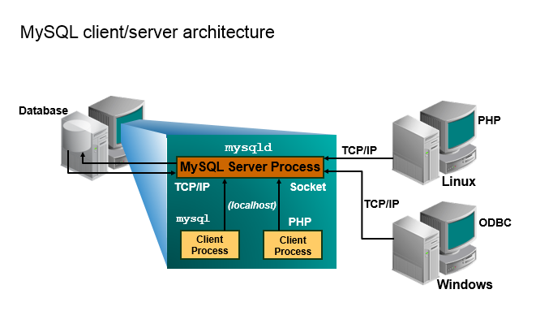

Communication Protocols
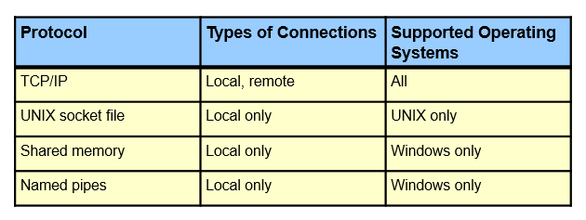
- Protocols are implemented in the client libraries and drivers.
- The speed of a connection protocol varies with the local settings.
LAMP Stack
- MySQL is the database component in the LAMP stack, which has become the preferred stack for web applications:
  - Linux: Operating system
  - Apache: Web server
  - MySQL: Relational Database Management System
  - PHP/Perl/Python: Programming languages
- The LAMP stack offers many degrees of freedom.
- You can go from LAMP to WAMP (Windows).
Installing MySQL
- You can download MySQL products from:
  - Community: http://dev.mysql.com/downloads
  - Enterprise: https://edelivery.oracle.com/
- The Windows operating system is used for this course.
- The MySQL installer for Windows is recommended:
  - http://dev.mysql.com/downloads/installer/
  - Installs several MySQL products
- Example databases for testing MySQL features:
  - The world_innodb database is used for examples and practices in this course.
  - This and other sample databases are available (free) online.
Configuration
Starting the MySQL Command-Line Client
Start the mysql client with the following command:
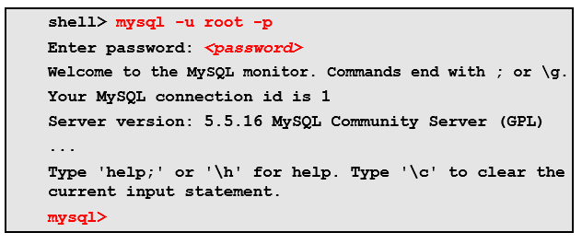
Startup Command-Line Options
Get a full list of options by using –-help:
- Some primary options:
  - -h: Host name or IP address
  - -u: Username
  - -p: Password
  - <database>: Database name
  - <: Input script
  - >: Output file name
  - -b: Beeps
- Syntax example:

Keyboard Editing
mysql client command-line editing methods:
- Keyboard directional arrows
- Command history preserved during session
- Interrupt a query
- Full readline capabilities under Linux
- Close quotes
- Copy and paste into window
Tee File
  - The tee file is a text file that logs all mysql client statements and their output.
  - Everything you see displayed on the screen is appended into a given file.
  - You can enable this feature interactively within the mysql client with the tee command:
mysql> tee session_tee_log.txt
  - The tee file can be disabled with the notee command.
  - Executing tee again re-enables logging.
  - View the text file from the file location by using the command-line text editor or Windows Explorer.
Exporting Data
- Backups are important!
- Backup principles:
  - Perform regularly.
  - Provide consistent and meaningful naming scheme.
  - Expire backup files.
  - Include with regular system backups.
- Reasons for exporting data:
  - Copying databases from one server to another:
    - From within the same host
    - To another host
  - Testing a new MySQL release with real data
  - Transferring data from one RDBMS to another
Exporting with a Query
- Write query results directly into a file by using SELECT with the INTO OUTFILE clause.
- Example:
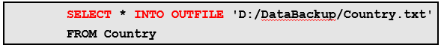
  - The name of the file indicates the location of the write.
- Default file format:
  - Values are delimited by tab characters.
  - Lines are terminated with newlines.
- The file format can be changed by using specific INTO OUTFILE options.
Exporting with a Query: INTO OUTFILE
INTO OUTFILE changes the standard SELECT operation:
- A file is written to the server host rather than to the executing client.
- Data is written to a new file only; there are no overwrites.
- The file contains one line per row selected by the statement.
- The user that executes the statement must have the FILE privilege.
- The file is created with file system access permissions.
Exporting with a Query: CSV Format
- Create a text file that contains information in
comma-separated values (CSV) format:
  - Values are enclosed in double quotation marks.
  - Lines are terminated by carriage returns.
- Example:
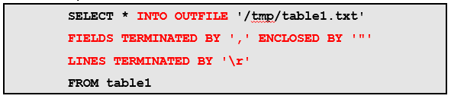
Importing Data
New data can be imported into a database by using a MySQL (.sql) statement file, which contains all the information needed to create tables.
- Example: Import the world_innodb database from file by using the mysql command.

  - Use the input operator (<) to indicate the SQL file name.
- Example: Import the data file within the mysql client.
Caution: Do not import over an existing database file with the same name.
Shell-level client commands do not require a semicolon (;) at the end of the statement.
A text file (.txt) can also be used to import data.
Importing from a Data File
You should know the following characteristics of the data file:
- The column value separator
- The order of the columns
- The row separator
- The file system where the file resides
- What are the values enclosed within? (example: double quotation marks)
- Are the column names specified in the file?
- Is there a header indicating rows of the table to skip before importing?
- Are privileges required to access the file?
Importing with the LOAD DATA INFILE Statement
- LOAD DATA INFILE is the reverse operation of SELECT with INTO OUTFILE.
  - However, it uses similar clauses and format specifiers.
- It reads row values from a file into a table.
- Files can be in tab-delimited or comma-separated format.
- Example:

- MySQL assumes that the file is located on the server host in the database data directory.
The simplest form of the LOAD DATA INFILE statement specifies only the name of the data file and the table into which to load the file, as shown in the example in the slide.
The syntax for LOAD DATA INFILE is as follows, where optional parts of the statement are indicated by square brackets:
LOAD DATA [LOCAL] INFILE 'file_name'
[IGNORE | REPLACE]
INTO TABLE table_name
format_specifiers
[IGNORE n LINES]
[(column_list)]
[SET (assignment_list)]
Importing with LOAD DATA INFILE: CSV Format
- Import a text file that contains information in
comma-separated values format.
- Example:
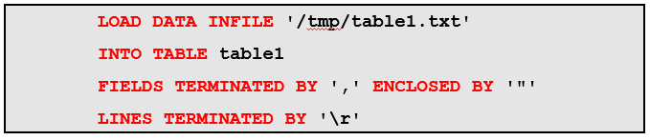
The file name is given as a quoted string. On Windows, the pathname separator character is “\”, but MySQL treats the backslash as the escape character in strings. To deal with this issue, write separators in Windows pathnames either as “/” or as “\\”. To load a file named D:\mydata\data.txt, specify the file name as shown in either of the following statements:
LOAD DATA INFILE 'D:\\mydata\\data.txt' INTO TABLE t
The example in the slide shows how to use a LOAD DATA INFILE statement to import a file named /tmp/data.txt that contains information in comma-separated values (CSV) format, with values enclosed within double quotation marks and lines terminated by carriage returns into a table named table1.
Exercise

Question No. 1
Using SELECT statement find the version of the server you are running and print the name of the current database?
Question No. 2
Write the statement to export tables from MySQL DBMS?
Question No. 3
Write the statement to log all SQL statements and their results in a text file.
Feedback

References:
- https://www.w3resource.com/sql/tutorials.php
- https://docs.microsoft.com/
- https://www.w3schools.com/sql/default.asp
- https://www.sqlservertutorial.net/
- https://www.geeksforgeeks.org/
- Database_Management_Systems_3rd_Edition_by_Raghu_Ramakrishnan_Johannes_Gehrke

